 “Ordo Franciscanus Saecularis”
San Jose Fraternity San Antonio, Texas Secular Franciscan Order

March 2025
Congratulations to our newly elected Fraternity Council
Minister: Suzanne Salinas-Valdillez, ofs
Vice Minister: Mary Basile, ofs
Secretary: Judith Hooge, ofs
Treasurer: George Irving, ofs
Formation Director: María de Jesús Ríos, ofs
Spiritual Assistant Friar Dennis Schafer, ofm

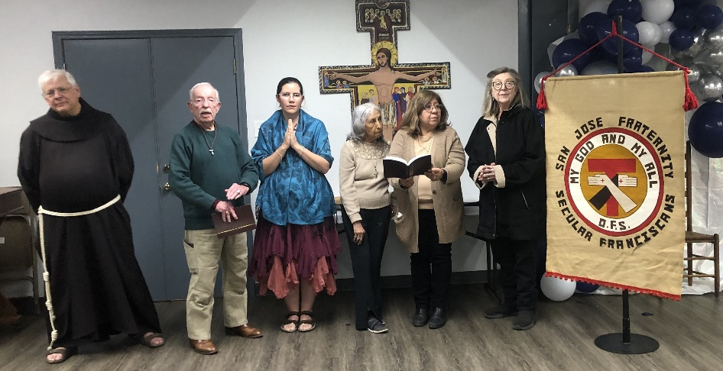
Pictured with Fr. Dennis Schafer, ofm, Spiritual Assistant for San Jose Fraternity is the newly elected Fraternity Council (L to R); George Irving, ofs, Treasurer, Mary Basile, ofs, Vice Minister, Maria de Jesus Rios, ofs, Formation Director, Suzanne Salinas-Valdillez, ofs, Minister, and Judith Hooge, ofs, Secretary. The Elective Chapter was held on Sunday the 16th of February 2025. Patsy Philipps, ofs, was the Regional Elective Official.

Next Fraternity Meeting: Sunday, March 16, 2025 (3rd Sunday)
San Jose Mission’s St. Francis Parish Center

12:00-12:30PM Professed Member Arrival & Social Time – bring your food items. We will eat first before the meeting. Please bring canned goods (the pop-top kind) for our donation to St. Vincent de Paul at one of the San Antonio Parishes. Please also bring any socks, gloves, or hats for our outreach to the homeless. Please bring pot luck food items.

2:00PM Fraternity Meeting

4:00PM Adjourn

Save the Dates:
- April 13, 2025, Fraternity Meeting, 2nd Sunday due to Easter being on 3rd Sunday.
- May 18, 2025, Fraternity Meeting, 3rd Sunday, St. Francis Parish Center @ San Jose
- June 8, 2025, Fraternity Meeting, 2nd Sunday due to Father’s day being on 3rd Sunday.
- July 20, 2025, Fraternity Meeting, 3rd Sunday, St. Francis Parish Center @ San Jose

PRAYER LIST: Continued prayers for health and spiritual blessings for all our members and their family members, and most especially:

Maggie Padilla, ofs, Lois Guckian, ofs, R. Michael Cook, ofs, Mary Zanyi, ofs, Petra & Gino Macias, ofs, Raquel Gomez, ofs, Ana Gaus, ofs, Maria de Jesus Rios, ofs, and Maria’s niece, Frances Rosales, ofs, Lydia Ramon, ofs, and Mary Solomon, ofs.

MARCH BIRTHDAY: Feliz Cumpleaños!!
Ana Gaus – March 12th
Sharonanne Brunet, March 16th

MARCH PROFESSION:
Alice McRae – March 21st

CALENDAR OF FRANCISCAN SAINTS for March – Month of the St. Joseph
1. Bl. Jean Kearney, Priest, religious of the Franciscan 1st Order, martyr 1653
2. St. Agnes de Prague, Virgin, of the Franciscan 2nd-Order; a "Poor Clare" sister, d. 1282
3. Bl. Innocent of Berzo, Priest, Capuchin, d. 1890
4. Bl. Martyrs of the Franciscan 1st Order of Gondar (Ethiopia), d. 1716
5. St. John-Joseph of the Cross, Priest, religious of the Franciscan 1st Order, d. 1734
6. St. Colette de Corbie, Virgin, of the Franciscan 2nd-Order; a "Poor Clare" sister, d. 1447
7. Bl. Christopher of Milan, Priest, religious of the Franciscan 1st Order, d. 1485
8. St. Jean de Dieu, Priest, had been a tertiary before founding or joining another religious Institute, d. 1550
9. St. Frances of Rome, Virgin, had been a tertiary before founding or joining another religious Institute, d. 1440
10. St. Catherine of Bologne, Virgin of the Franciscan 2nd-Order; a "Poor Clare" sister, d. 1463
11. Bl. John Baptist Righi of Fabriano, Priest, religious of the Franciscan 1st Order, d. 1539
12. Bl. Louis Orione, Priest, Franciscan Third Order Secular, d. 1940
13. Bl. Agnellus of Pisa, Priest, religious of the Franciscan 1st Order, d. 1236
14. St. Catherine of Genoa, Virgin, Franciscan Third Order Secular, d. 1510
15. Bl. Louis of Casoria, Priest, religious of the Franciscan 1st Order, d. 1885
16. Bl. Torello of Poppi, Confessor, Franciscan Third Order Secular, d. 1282
17. Bl. Mark of Montegallo, Priest, religious of the Franciscan 1st Order, d. 1496
18. St. Salvator of Horta, lay brother, religious of the Franciscan 1st Order, d. 1567
19. Saint Joseph,
20. Bl. Hippolyte Galentini, Confessor, Franciscan Third Order Secular, d. 1620
21. Bl Amedee IX de Savoie, Confessor, Franciscan Third Order Secular, d. 1472
22. St. Benvenute of Osimo, Bishop, religious of the Franciscan 1st Order, d. 1282
23. Bl. Jeremy Lambertenghi, Priest, Franciscan Third Order Secular, d. 1513
24. Bl. Catherine de Suede, Virgin, had been a tertiary before founding or joining another religious Institute, d. 1381
25. Feast of the Annunciation of the Blessed Virgin Mary, Holy Day of Obligation for the Church
26. Blessed Didacus Joseph of Cadiz, Priest, Capuchin, d. 1801
27. Bl. Joseph-Sebastien Pelczar, Bishop, Franciscan Third Order Secular, d. 1924..
28. St. John of Capistrano, Priest, religious of the Franciscan 1st Order, d. 1456
29. Bl. Jane Mary of Maille, Virgin, Franciscan Third Order Secular, d. 1414
30. St. Peter Regalado, Priest, religious of the Franciscan 1st Order, d. 1486
31. St. Leonard Murialdo, Priest, Franciscan Third Order Secular, d. 1900

Apostolate for Food Banks: Please bring can goods (the Pop-Top kind only) to our monthly gatherings. We will collect these and distribute to one of our local parishes who have food distribution to the poor.
Apostolate for Homeless: Please bring items to pass to the homeless at the breakfast at Our Lady of Guadalupe Shrine. Needed are: SOCKS, Hats, Glover, Scarfs.
Another Apostolate: At Our Lady of Guadalupe Shrine, Br. Jaime’s Franciscan Outreach Ministry is at work every week usually in the mornings (Mon, Thru, & Fri) around 8:00am. We can try to help in the kitchen during the week to help Br. Joseph. They serve around 9:30-12. They start cooking around 8:30am.

Right to Life Rosaries were raffled during the Election Chapter at our February Gathering. A friend of one of our members donated three Right to Life Rosaries. Each is a gorgeous rosary with remembrances of the value of a developing human life in each decade.
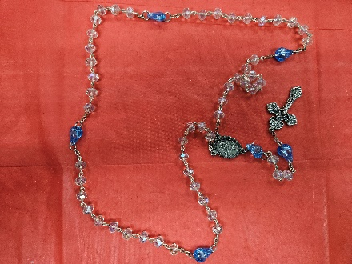

Catechism of the Catholic Church
177. Who are the faithful? The Christian faithful are those who, inasmuch as they have been incorporated in Christ through Baptism, have been constituted as the people of God; for this reason, since they have become sharers in Christ's priestly, prophetic and royal office in their own manner, they are called to exercise the mission which God has entrusted to the Church. There exists a true equality among them in their dignity as children of God.
Further reading: CCC 871-872
178. How are the people of God formed? Among the faithful by divine institution there exist sacred ministers who have received the sacrament of Holy Orders and who form the hierarchy of the Church. The other members of the Church are called the laity. In both the hierarchy and the laity there are certain of the faithful who are consecrated in a special manner of God by the profession of the evangelical counsels: chastity or celibacy, poverty, and obedience.
Further reading: CCC 873, 934

179. Why did Christ institute an ecclesiastical hierarchy? Christ instituted an ecclesiastical hierarchy with the mission of feeding the people of God in his name and for his purpose gave it authority. The hierarchy is formed of sacred ministers,; bishops, priests, and deacons. Thanks to the sacrament of Orders, bishops and priests act in the exercise of their ministry in the name and person of Christ the Head. Deacons minister to the people of God in the diakonia (service) of word, liturgy, and charity. Further reading: CCC 874-876, 935
180. How is the collegial dimension of Church ministry carried out? After the example of the twelve Apostles who were chosen and sent out together by Christ, the unity of the Church's hierarchy is at the service of the communion of all the faithful. Every bishop exercises his ministry as a member of the episcopal college in communion with the Pope and shares with him in the care of the universal Church. Priests exercise their ministry in the presbyterate of the local Church in communion with their own bishop and under his direction.
Further reading: CCC 876-877

181. Why does ecclesial ministry also have a person character? Ecclesial ministry also have a personal character in as much as each minister, in virtue of the sacrament of Holy Orders, is responsible before Christ who called him personally and conferred on him his mission.
Further reading: CCC 878-879

182. What is the mission of the Pope? The Pope, Bishop of Rome and the Successor of Saint Peter, is the perpetual, visible source and foundation of the unity of the Church. He is the vicar of Christ, the head of the College of bishops and pastor of the universal Church over which he has by divine institution full, supreme, immediate, and universal power.
Further reading: CCC 880-882, 936-937
183. What is the competence of the college of bishops? The college of bishops in union with the Pope, and never without him, also exercises supreme and full authority over the Church.
Further reading: CCC 883-885

184. How do the bishops carry out their mission of teaching? Since they are authentic witnesses of the apostolic faith and are invested with the authority of Christ, the bishops in union with the Pope have the duty of proclaiming the Gospel faithfully and authoritatively to all. By means of a supernatural sense of faith, the people of God unfailingly adhere to the faith under the guidance of the living Magisterium of the Church. Further reading: CCC 888-890, 939

Pax et Bonum! Peace and All Good!! Paz y Bien!

Suzanne Salinas-Valdillez, ofs, Minister; 7710 Tourney Oak Dr. San Antonio, TX 78213

