 “Ordo Franciscanus Saecularis”
San Jose Fraternity San Antonio, Texas Secular Franciscan Order

May 2025
Congratulations to our new Fraternity Council, Elected in Feb 2025
Minister: Suzanne Salinas-Valdillez, ofs
Vice Minister: Mary Basile, ofs
Secretary: Judith Hooge, ofs
Treasurer: George Irving, ofs
Formation Director: María de Jesús Ríos, ofs
Spiritual Assistant Friar Dennis Schafer, ofm

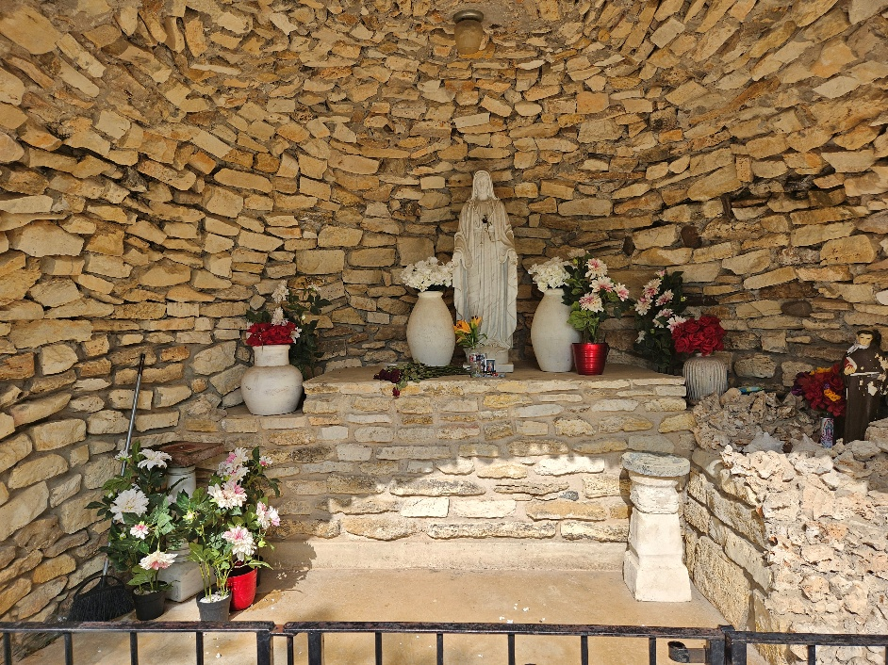
Our Lady Mary’s Grotto at St. Peter the Apostle Catholic Church in Boerne, TX

Next Fraternity Meeting: Sunday, May 18, 2025 (3rd Sunday)
San Jose Mission’s St. Francis Parish Center

12:00-12:30PM Professed Member Arrival & Social Time – bring your food items. Please bring canned goods (the pop-top kind) for our donation to St. Vincent de Paul at one of the San Antonio Parishes. Please also bring any socks, gloves, or hats for our outreach to the homeless.

12:30PM Rosary
1:00PM Mass of Remembrance for R. Michael Cook, ofs, in the Chapel

1:00PM Fraternity Social and Meeting

4:00PM Adjourn

Save the Dates:
- June 8, 2025, Fraternity Meeting, 2nd Sunday due to Father’s Day on 3rd Sunday.
- July 20, 2025, Fraternity Meeting, 3rd Sunday, St. Francis Parish Center @ San Jose
- August 20, 2025, Fraternity Meeting, 3rd Sun, St. Francis Parish Center @ San Jose

PRAYER LIST: Continued prayers for health and spiritual blessings for all our members and their family members, and most especially:

The repose of the soul of R. Michael Cook, ofs, on Sunday March 23, 2025. We will celebrate a memorial Mass for R. Michael on the 18th of May (our meeting day) at 1:00PM in the little chapel next to the parish offices. Dr. Dennis will be the Celebrant.

The repose of the soul of our Pope Francis.

Maggie Padilla, ofs, Lois Guckian, ofs, Mary Zanyi, ofs, Petra & Gino Macias, ofs, Raquel Gomez, ofs, Ana Gaus, ofs, Maria de Jesus Rios, ofs, and Maria’s niece, Frances Rosales, ofs, Lydia Ramon, ofs, and Mary Solomon, ofs.

MAY BIRTHDAY: Feliz Cumpleaños!!
Lydia Ramon, ofs May 16th

MAY PROFESSION:
Flo Sepulveda, ofs May 19th

CALENDAR OF FRANCISCAN SAINTS for May – Month of Holy Virgin Mary
1. Feast of Saint Joseph the Artisan
2. St. Richard Pampuri, Confessor, had been a tertiary before founding or joining another religious Institute, d. 1930
3. Bl. Edouard-Joseph Rosas, Bishop, Franciscan Third Order Secular, d. 1903
4. Bl. Ladislas de Gielniow, Priest, religious of the Franciscan 1st Order, d. 1505
5. Bl. Beinvenu Mareni, lay brother, religious of the Franciscan 1st Order, d. 1289
6. Bl. Marie-Catherine Troijani, Virgin, religious of the Third-Order Regular [living in community, under a Rule], d. 1897
7. Bl. Anne-Rose Gattorno, Virgin, religious of the Third-Order Regular [living in community, under a Rule], d. 1900
8. Feast of Mary Mediatrix of all Graces
9. Bl. Antoine Bajewski, Priest, Conventual religious, martyr 1941
10. Bl. Marie-Bernard Butler, Virgin, religious of the Third-Order Regular [living in community, under a Rule], d. 1924
11. St. Gemme de Sulmona, Virgin, Franciscan Third Order Secular, d. 1439
12. St Ignatius of Laconi, lay brother, Capuchin religious, d. 1781
13. St. Michael Garicoits, Priest, had been a tertiary before founding or joining another religious Institute, d. 1863
14. St. Marie-Dominique Mazzarello, Virgin, had been a tertiary before founding or joining another religious Institute, d. 1881
15. St. Jean-Baptiste de la Salle, Priest, had been a tertiary before founding or joining another religious Institute, d. 1719
16. St. Theophilus of Corte, Priest, religious of the Franciscan 1st Order, d. 1740
17. St. Paschal of Baylon, lay brother, religious of the Franciscan 1st Order, d. 1592
18. St. Felix de Cantalice, lay brother, Capuchin religious, 1587
19. St. Yves, Priest, Franciscan Third Order Secular, d. 1303
20. St. Bernardine of Siena, Priest, religious of the Franciscan 1st Order, d. 1444
21. St. Crispin of Viterbo, lay brother, Capuchin religious, d. 1750
22. St. Joaquina Vedruna, Virgin, had been a tertiary before founding or joining another religious Institute, d. 1854
23. Bl. Gerard of Villamagna, Confessor, Franciscan Third Order Secular, d. 1242
24. Bl. John of Prado, Priest, religious of the Franciscan 1st Order, martyr 1631
25. Dedication of the Basilica in Assisi, 1253
26. St. Philippe Neri, Priest, had been a tertiary before founding or joining another religious Institute, d. 1595; memorial of St Mariane of Jesus Parades, Virgin, Franciscan Third Order Secular, d. 1645
27. Bl. Gerard of Lunel, Confessor, Franciscan Third Order Secular, d. 1270
28. St. Jean-Baptiste Rossi, Priest, Franciscan Third Order Secular, d. 1764
29. Bl. Etienne et Raymond, Priest, religious of the Franciscan 1st Order, d. 1242
30. St. Joan of Arc, Virgin, Franciscan Third Order Secular, d. 1431 King Saint Fernando III, Confessor, Franciscan Third Order Secular, d. 1252
31. Feast of the Queenship of Mary, Public Consecration of the world to the Immaculate Heart of Mary Novena in preparation of the feast of Pentecost Pentecost - Plenary Indulgence – Chant in public the Veni Creator Sacred Heart – Plenary Indulgence - Public recitation of the Act of Reparation

Apostolate for Food Banks: Please bring can goods (the Pop-Top kind only) to our monthly gatherings. We will collect these and distribute to one of our local parishes who have food distribution to the poor.
Apostolate for Homeless: Please bring items to pass to the homeless at the breakfast at Our Lady of Guadalupe Shrine. Needed are: SOCKS, Hats, Glover, Scarfs.
Another Apostolate: At Our Lady of Guadalupe Shrine, Br. Jaime’s Franciscan Outreach Ministry is at work every week usually in the mornings (Mon, Thru, & Fri) around 8:00am. We can try to help in the kitchen during the week to help Br. Joseph. They serve around 9:30-12. They start cooking around 8:30am.

Catechism of the Catholic Church

192. What is the consecrated life? The consecrated life is a state of life recognized by the Church. It is a free response to a special call from Christ by which those consecrated give themselves completely to God and strive for the perfection of charity moved by the Holy Spirit. This consecration is characterized by the practice of the evangelical counsels. Further reading: CCC 914-916, 944
193. What can the consecrated life give to the mission of the Church? The consecrated life participates in the mission of the Church by means of a complete dedication to Christ and to one's brothers and sisters witnessing to the hope of the heavenly Kingdom. Further reading: CCC 931-933, 945

194. What is the meaning of the "communion of saints"? This expression indicates first of all the common sharing of all the members of the Church in holy things (sancta): the faith, the sacraments, especially the Eucharist, the charisms, and the other spiritual gifts. At the root of this communion is love which "does not seek its own interests" (1 Corinthians 13:5) but leads the faithful to "hold everything in common" (Acts 4:32), even to put one's own material goods at the service of the most poor.
Further reading: CCC 946-953, 960
195. What else does "the communion of saints" mean? This expression also refers to the communion between holy person (sancti); that is, between those who by grace are united to the dead and risen Christ. Some are pilgrims on the earth; others, having passed from this life, are undergoing purification and are helped also by our prayers. Others already enjoy the glory of God and intercede for us. All of these together form in Christ one family, the Church, to the praise and glory of the Trinity.
Further reading: CCC 954-959, 961-962

196. In what sense is the Blessed Virgin Mary the Mother of the Church? The Blessed Virgin Mary is the Mother of the Church in the order of grace because she gave birth to Jesus, the Son of God, the Head of the body which is the Church. When he was dying on the cross Jesus gave his mother to his disciple with the words, "Behold your mother" (John 19:27). Further reading: CCC 963-964, 973
197. How does the Virgin Mary help the Church? After the Ascension of her Son, the Virgin Mary aided the beginning of the Church with her prayers. Even after her Assumption into heaven, she continues to intercede for her children, to be a model of faith and charity for all, and to exercise over them a salutary influence deriving from the superabundant merits of Christ. The faithful see in Mary an image and an anticipation of the resurrection that awaits them and they invoke her as advocate, helper, benefactress and mediatrix. Further reading: CCC 965-970, 974-975

Pax et Bonum! Peace and All Good!! Paz y Bien!

Suzanne Salinas-Valdillez, ofs, Minister; 7710 Tourney Oak Dr. San Antonio, TX 78213

