 “Ordo Franciscanus Saecularis”
San Jose Fraternity San Antonio, Texas Secular Franciscan Order

June 2025
Fraternity Council, Elected in Feb 2025
Minister: Suzanne Salinas-Valdillez, ofs
Vice Minister: Mary Basile, ofs
Secretary: Judith Hooge, ofs
Treasurer: George Irving, ofs
Formation Director: María de Jesús Ríos, ofs
Spiritual Assistant Friar Dennis Schafer, ofm
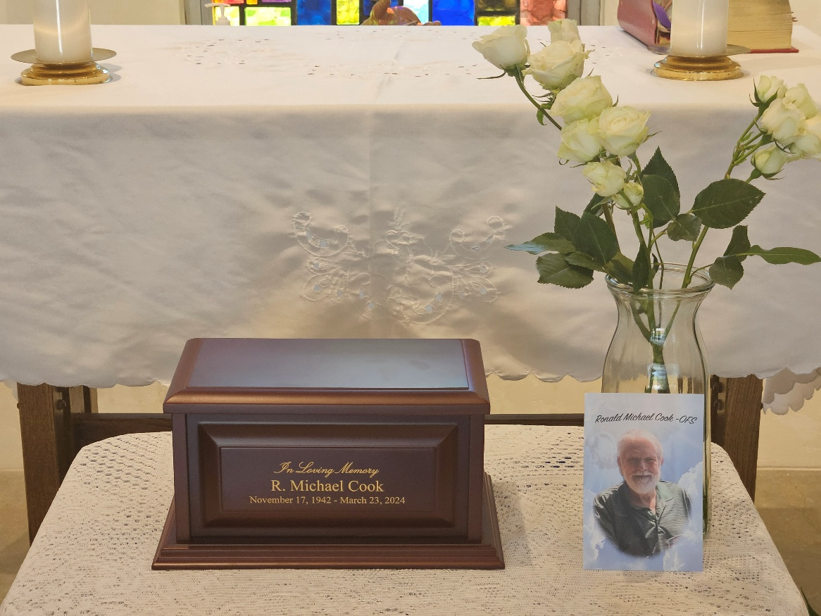

Please pray for the repose of the soul of R. Michael Cook, ofs. We celebrated a memorial Mass and Crown Rosary for R. Michael on the 18th of May 2025 (our meeting day) at 1:00PM in the Juan Diego chapel next to the San Jose Mission parish office. Fr. Dennis, ofm was the Celebrant.

Next Fraternity Meeting: Sunday, June 8, 2025 (2nd Sunday)
San Jose Mission’s St. Francis Parish Center

12:00-12:30PM Professed Member Arrival & Social Time – bring your food items. Please bring canned goods (the pop-top kind) for our donation to St. Vincent de Paul at one of the San Antonio Parishes. Please also bring any socks, gloves, or hats for our outreach to the homeless.

12:30PM Rosary Followed by Liturgy of the Hours for the Solemnity of Pentecost
+
1:00PM Fraternity Social and Meeting

4:00PM Adjourn
Save the Dates:
- Regional Chapter, Cedar Brake Retreat Center, June 13-15, 2025 – A Fraternity Council event, others may attend if space available
- July 20, 2025, Fraternity Meeting, 3rd Sunday, St. Francis Parish Center @ San Jose
- August 2, 2025, the Portuncula Indulgence for the 2nd of August
- August 12: The feast day of St. Clare of Assisi, Virgin, Foundress of the Poor Clares, Plenary Indulgence for Tertiaries (Renewal of Engagements)
- August 20, 2025, Fraternity Meeting, 3rd Sun, St. Francis Parish Center @ San Jose
- Sept 21, 2025, Fraternity Meeting, 3rd Sun, St. Francis Parish Center @ San Jose

PRAYER LIST: Continued prayers for health and spiritual blessings for all our members and their family members, and most especially:

Maggie Padilla, ofs, Lois Guckian, ofs, Mary Zanyi, ofs, Petra & Gino Macias, ofs, Raquel Gomez, ofs, Ana Gaus, ofs, Maria de Jesus Rios, ofs, and Maria’s niece, Frances Rosales, ofs, Lydia Ramon, ofs, and Mary Solomon, ofs.

JUNE BIRTHDAY: Feliz Cumpleaños!!
Margarita Gonzalez ofs, June 5

JUNE PROFESSION:
Judith Hooge, ofs June 14, 2009

During our Business Meeting on 18 May 2025 the Fraternity voted unanimously to move Ana Gaus, ofs, from Voluntarily Withdrawn to Active Professed Member status.

CALENDAR OF FRANCISCAN SAINTS for June – Month of the Sacred Heart of Jesus
1. Bl. Felix of Nicosia, lay brother, Capuchin religious. d/ 1787
2. Bl. John Pelingotto, Confessor, Franciscan Third Order Secular, d. 1304
3. Bl. Andrew of Spello, Priest, religious of the Franciscan 1st Order, d. 1254
4. St. Francois Caracciolo, Priest, had been a tertiary before founding or joining another religious Institute, d. 1608
5. Bl Pacific of Cerano, Priest, religious of the Franciscan 1st Order, d. 1482
6. Bl. Lawrence of Villamagna, Priest, religious of the Franciscan 1st Order, d. 1535
7. Bl. Himiliana Cerchi, Virgin, Franciscan Third Order Secular, d. 1246
8. Bl. Nicolas de Gesturi, lay brother, Capuchin religious, d. 1958
9. Bl. Innocent Guz, Priest, Conventual religious, martyr 1940
10. Bl. Edouard Poppe, Priest, Franciscan Third Order Secular, d. 1924
11. Bl. Yolanda of Hungary, Virgin, of the Franciscan 2nd-Order; a "Poor Clare" sister, d. 1298
12. Bl. Floride Cevoli, Virgin, Capuchin religious, d. 1767
13. St. Anthony of Padua, Priest, religious of the Franciscan 1st Order, d. 1231 Plenary Indulgence for cordbearers
14. Bl. Zephirin Jimenez, Martyr, Franciscan Third Order Secular, d. 1936
15. St. Vincenta Gerosa, Virgin, had been a tertiary before founding or joining another religious Institute, d. 1847, and Saint Mary Bartholomea Capitanio.
16. Bl. Marie-Therese Scherer, Virgin, had been a tertiary before founding or joining another religious Institute, d. 1888
17. Bl. Peter Gambacorti, Confessor, Franciscan Third Order Secular, d. 1435
18. Bl. Guy of Cortona, Priest, religious of the Franciscan 1st Order, d. 1250
19. Bl. Achille Puchata, Priest, Conventual religious, martyr 1943
20. Bl. Micheline de Pesaro, Virgin, Franciscan Third Order Secular, d. 1356
21. Bl. Herman Stapien, Priest, Conventual religious, martyr 1943
22. St. Thomas More, Martyr, Franciscan Third Order Secular, d. 1943
23. St. Joseph Cafasso, Priest, Franciscan Third Order Secular, d. 1860
24. Nativity of St. John the Baptist
25. Bl. Bienvenu de Gubbio, lay brother, religious of the Franciscan 1st Order, d. 1232
26. Bl. Frederick Jassoone, Priest, religious of the Franciscan 1st Order, d. 1916
27. Bl. Marguerite Baeys, Virgin, Franciscan Third Order Secular, d. 1879
28. St. Barthelemie Capitanio, Virgin, had been a tertiary before founding or joining another religious Institute, d. 1833
29. Sts. Peter and Paul, Holy Day of Obligation, Plenary Indulgence
30. Bl. Raymond Lulle, Martyr, Franciscan Third Order Secular, d. 1315

Apostolate for Food Banks: Please bring can goods (the Pop-Top kind only) to our monthly gatherings. We will collect these and distribute to one of our local parishes who have food distribution to the poor.
Apostolate for Homeless: Please bring items to pass to the homeless at the breakfast at Our Lady of Guadalupe Shrine. Needed are: SOCKS, Hats, Glover, Scarfs.
Another Apostolate: At Our Lady of Guadalupe Shrine, Br. Jaime’s Franciscan Outreach Ministry is at work every week usually in the mornings (Mon, Thru, & Fri) around 8:00am. We can try to help in the kitchen during the week to help Br. Joseph. They serve around 9:30-12. They start cooking around 8:30am.
A New Apostolate: The Fraternity would like to join you in praying for those special people or intentions that often do not become verbalized. If you are praying for a particular person or intention, please write the person’s name or the intention subject on a piece of paper. You do not need to include your name. Place that paper in a special box at our next meeting and one of our members will take that paper and pray for the person or intention.
The Portiuncula Indulgence – August 2 – This is a Grace not to be missed—not only for yourself but for the many suffering souls in Purgatory.

Please make plans on Thursday, August 2, to attend Holy Mass and receive Communion.

The conditions to obtain the Plenary Indulgence of the Forgiveness of Assisi is (for oneself or for a departed soul) is as follows:
Sacramental Confession to be in God’s grace (during eight days before or after)
Participation in the Holy Mass and Eucharist
Recitation of The Apostles Creed, Our Father, Hail Mary, and Glory Be for the Pope’s Intentions

Catechism of the Catholic Church

198. What kind of devotion is directed to the holy Virgin? It is a singular kind of devotion which differs essentially from the cult of adoration given only to the Most Holy Trinity. This special veneration directed to Mary finds particular expression in the liturgical feasts dedicated to the Mother of God and in Marian prayers such as the holy Rosary which is a compendium of the whole Gospel. Further reading: CCC 971
199. In what way is the Blessed Virgin Mary the eschatological icon of the Church? Looking upon Mary, who is completely holy and already glorified in body and soul, the Church contemplates in her what she herself is called to be on earth and what she will be in the homeland of heaven. Further reading: CCC 972

200. How are sins remitted? The first and chief sacrament for the forgiveness of sins in Baptism. For those sins committed after Baptism, Christ instituted the sacrament of Reconciliation or Penance through which a baptized person is reconciled with God and with the Church. Further reading: CCC 876-980, 984-985
201. Why does the Church have the power to forgive sins? The Church has the mission and the power to forgive sins because Christ himself has conferred it upon her: "Receive the Holy Spirit, if you forgive the sins of any, they are forgiven; if you retain the sins of any, they are retained" (John 20:22-23). Further reading: CCC 981-983 ,986-987

202. What is the meaning of the term "body" (or "flesh") and what importance does it have? The resurrection of the flesh is the literal formulation in the Apostles Creed for the resurrection of the body. The term "flesh" refers to humanity in its state of weakness and mortality. "The flesh is the hinge of salvation" (Tertullian). We believe in God the Creator of the flesh; we believe in the Word made flesh in order to redeem flesh; and we believe in the resurrection of flesh which is the fulfillment of both the creation and the redeem flesh; and we believe in the resurrection of flesh which is the fulfillment of both the creation and the redemption of the flesh. Further reading: CCC 990-1015
203. What is meant by the "resurrection of the body"? This means that the definitive state of man will not be one in which his spiritual soul separates from his body. Even our mortal bodies will one day come to life again. Further reading: CCC 990

Pax et Bonum! Peace and All Good!! Paz y Bien!

Suzanne Salinas-Valdillez, ofs, Minister; 7710 Tourney Oak Dr. San Antonio, TX 78213

