 “Ordo Franciscanus Saecularis”
San Jose Fraternity San Antonio, Texas Secular Franciscan Order

July 2025
Fraternity Council
Minister: Suzanne Salinas-Valdillez, ofs
Vice Minister: Mary Basile, ofs
Secretary: Judith Hooge, ofs
Treasurer: George Irving, ofs
Formation Director: María de Jesús Ríos, ofs
Spiritual Assistant Friar Dennis Schafer, ofm

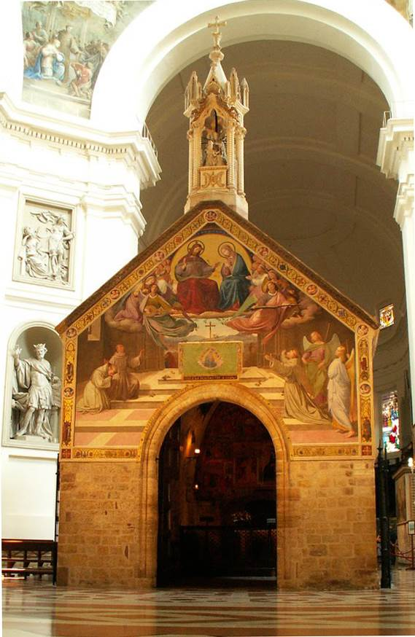
The Little Portion of St. Francis. The Portiuncula chapel located within the Basilica of St. Mary of the Angels in Assisi, Italy. See the paragraph below on the Portuncula Indulgence for the 2nd of August

Next Fraternity Meeting: Sunday, July 20, 2025 (3rd Sunday)
Our Lady of Guadalupe Shrine
1321 El Passo St. San Antonio, TX 78207

11:30AM Mass in the Our Lady of Guadalupe Shrine followed by the Liturgy of the hours for the Sixteenth Sunday in Ordinary Time.

1:00PM Tour of the Facilities where Bro Jaime and volunteers serve the homeless.

Do NOT bring food items.
Please bring canned goods (the pop-top kind) for our donation to St. Vincent de Paul at one of the San Antonio Parishes. Please also bring any socks, gloves, or hats for our outreach to the homeless.

1:30PM There may be a brief meeting with important items of interest

Save the Dates:
- August 2, 2025, the Portuncula Indulgence for the 2nd of August
- August 12: The feast day of St. Clare of Assisi, Virgin, Foundress of the Poor Clares, Plenary Indulgence for Tertiaries (Renewal of Engagements)
- August 20, 2025, Fraternity Meeting, 3rd Sun, St. Francis Parish Center @ San Jose
- Sept 21, 2025, Fraternity Meeting, 3rd Sun, St. Francis Parish Center @ San Jose
- October 19, 2025 Fraternity Meeting, 3rd Sun, St. Francis Center @ San Jose Mission

PRAYER LIST: Continued prayers for health and spiritual blessings for all our members and their family members, and most especially:

Maggie Padilla, ofs, Lois Guckian, ofs, Mary Zanyi, ofs, Petra & Gino Macias, ofs, Raquel Gomez, ofs, Ana Gaus, ofs, Maria de Jesus Rios, ofs, and Maria’s niece, Frances Rosales, ofs, Lydia Ramon, ofs, and Mary Solomon, ofs.

JULY BIRTHDAY: Feliz Cumpleaños!!
David Basile – 7/30
Mary Basile – 7/18
Yolanda Montoya – 7/21

JULY PROFESSION: None

CALENDAR OF FRANCISCAN SAINTS for July – Month of the Precious Blood of Our Lord Jesus Christ
1. Feast of the Precious Blood of Our Lord Jesus Christ
2. Feast of the Visitation of Our Lady
3. Bl. Marie Anne Fontcuberta, Virgin, religious of the Third-Order Regular [living in community, under a Rule], d. 1886
4. 40 Martyrs of China, religious of the Franciscan 1st Order and Franciscan Third Order Secular, d. 1900
5. Bl. Ignace Falzon, Confessor, Franciscan Third Order Secular, d. 1865
6. St. Maria Goretti, Virgin Martyr, Cordbearer, d. 1902
7. Bl. Oddino Barrotti, Priest, Franciscan Third Order Secular, d. 1400
8. St. Elizabeth of Portugal, Virgin, Franciscan Third Order Secular, d. 1336
9. St. Veronica Giuliani, Virgin, Capuchin religious, d. 1727
10. 8 Martyrs religious of the Franciscan 1st Order of Damas, d. 1860
11. 11 Martyrs religious of the Franciscan 1st Order of Holland, d. 1572
12. Sts. Geoffrey and Joachim, Priests, religious of the Franciscan 1st Order, martyrs 1679
13. St. Francis Solano, Priest, religious of the Franciscan 1st Order, d. 1610
14. St. Bonaventure, Bishop, Doctor of the Church, religious of the Franciscan 1st Order, d. 1274
15. Bl. Bernard of Baden, Confessor, Franciscan Third Order Secular, d. 1458
16. Our Lady of Mount Carmel; St. Marie-Madeleine Postel, Virgin, religious of the Third-Order Regular [living in community, under a Rule], d. 1846
17. Bl. Pierre De Foligno, Confessor, Franciscan Third Order Secular, d. 1614
18. St. Camillus de Lellis, Priest, had been a tertiary before founding or joining another religious Institute, d. 1614
19. St. Vincent de Paul, Priest, had been a tertiary before founding or joining another religious Institute, d. 1660
20. St. Jerome Emilien, Priest, had been a tertiary before founding or joining another religious Institute, d. 1537
21. St. Lawrence of Brindisi, Priest, Capuchin religious, Doctor of the Church, d. 1619
22. Bl. Angelina of Marciano, Virgin, religious of the Third-Order Regular [living in community, under a Rule], d. 1435
23. Bl. Louise of Savoy, Virgin, of the Franciscan 2nd-Order; a "Poor Clare" sister, d. 1503
24. Bl. Modestin de Jesus-Marie, Priest, religious of the Franciscan 1st Order, d. 1864
25. Bl. Antoine Lucci, Bishop, Conventual religious, d. 1752
26. St. Anne, mother of the Blessed Virgin Mary
27. Bl. Mary Magdalene Martinengo, Virgin, Capuchin, d. 1737
28. Bl. Marie-Therese of the Infant Jesus, Virgin, Capuchin, martyr 1941
29. Bl. Alphonse de l’Immaculee, virgin, religious of the Third-Order Regular [living in community, under a Rule], d. 1946
30. St. Leopold de Castelnovo, Priest, Capuchin religious, d. 1942
31. St. Ignace de Loyola, Priest, had been a tertiary before founding or joining another religious Institute, d. 1556

Apostolate for Food Banks: Please bring can goods (the Pop-Top kind only) to our monthly gatherings. We will collect these and distribute to one of our local parishes who have food distribution to the poor.
Apostolate for Homeless: Please bring items to pass to the homeless at the breakfast at Our Lady of Guadalupe Shrine. Needed are: SOCKS, Hats, Glover, Scarfs.
Another Apostolate: At Our Lady of Guadalupe Shrine, Br. Jaime’s Franciscan Outreach Ministry is at work every week usually in the mornings (Mon, Thru, & Fri) around 8:00am. We can try to help in the kitchen during the week to help Br. Joseph. They serve around 9:30-12. They start cooking around 8:30am.
A New Apostolate: The Fraternity is considering praying for those special people or intentions that often do not become verbalized. We are considering placing a box somewhere in San Jose Mission Church where anyone may place a written note with the person’s name or the intention subject. Our Fraternity would then pray for that special intention.
TAU Newsletter of the National Fraternity: The NAFRA Newsletter for Spring 2025 was distributed to members attending the June San Jose Fraternity Gathering. It may be found on the following Internet connection: TAU-USA Magazine – Secular Franciscan Order – USA
The Portiuncula Indulgence – August 2 – This is a Grace not to be missed—not only for yourself but for the many suffering souls in Purgatory.

Please make plans on Thursday, August 2, to attend Holy Mass and receive Communion.

The conditions to obtain the Plenary Indulgence of the Forgiveness of Assisi is (for oneself or for a departed soul) is as follows:
Sacramental Confession to be in God’s grace (during eight days before or after the 2nd of August)
Participation in the Holy Mass and Eucharist
Recitation of The Apostles Creed, Our Father, Hail Mary, and Glory Be for the Pope’s Intentions

Catechism of the Catholic Church

204. What is the relationship between the Resurrection of Christ and our resurrection?
Just as Christ is truly risen from the dead and now lives forever, so he himself will raise everyone on the last day with an incorruptible body: "Those who have done good will rise to the resurrection of life and those who have done evil to the resurrection of condemnation" (John 5:29). Further reading: CCC 998, 1002-1003
205. What happens to our body and our soul after death? After death, which is the separation of the body and the soul, the body becomes corrupt while the soul, which is immortal, goes to meet the judgment of God and awaits its reunion with the body when it will rise transformed at the time of the return of the Lord. How the resurrection of the body will come about exceeds the possibilities of our imagination and understanding. Further reading: CCC 992-1004, 1016-1018
206. What does it mean to die in Christ Jesus? Dying in Christ Jesus means to die in the state of God's grace without any mortal sin. A believer in Christ, following his example, is thus able to transform his own death into an act of obedience and love for the Father. "This saying is sure: if we have died with him, we will also live with him" (2 Timothy 2:11). Further reading: CCC 992-1004, 1016-1018

207. What is life everlasting? Eternal life is that life which begins immediately after death. It will have no end. It will be preceded for each person by a particular judgment at the hands of Christ who is the Judge of the living and the dead. This particular judgement will be confirmed in the final judgment. Further reading: CCC 1020, 1051
208. What is the particular judgment? It is the judgment of the immediate retribution which each one after death will receive from God in his immortal soul in accord with his faith and his works. This retribution consists in entrance into the happiness of heaven, immediately or after an appropriate purification, or entry into the eternal damnation of hell. Further reading: CCC 1021-1022, 1051

Pax et Bonum! Peace and All Good!! Paz y Bien!

Suzanne Salinas-Valdillez, ofs, Minister; 7710 Tourney Oak Dr. San Antonio, TX 78213

