 “Ordo Franciscanus Saecularis”
San Jose Fraternity San Antonio, Texas Secular Franciscan Order

January 2026
Fraternity Council
Minister: Suzanne Salinas-Valdillez, ofs
Vice Minister: Mary Basile, ofs
Secretary: Judith Hooge, ofs
Treasurer: George Irving, ofs
Formation Director: María de Jesús Ríos, ofs
Spiritual Assistant Friar Dennis Schafer, ofm

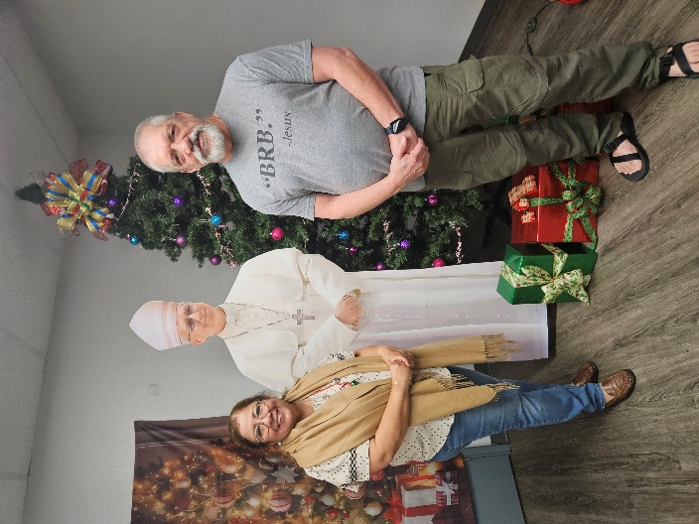
San Jose Fraternity minister, Suzanne Salinas-Valdillez, ofs,
congratulates James Smith following his Welcome Ceremony into the Secular Franciscan Order at our December 2025 gathering.

Next Fraternity Meeting: Sunday, January 18, 2026 (3rd Sunday)
St. Francis Parish Hall, San Jose Mission, San Antonio, TX

12:00-12:30PM Professed Member Arrival & Social Time – bring your food items. Please bring canned goods (the pop-top kind) for our donation to St. Vincent de Paul at one of the San Antonio Parishes. Please also bring any socks, gloves, or hats for our outreach to the homeless.
(A-J) Side Dishes
(K-Z) Main Dishes

12:30PM Rosary followed by Liturgy for the XXXX; and Ongoing Formation

1:00PM Fraternity Social and Meeting

4:00PM Adjourn
Save the Dates:
- Feb 15, 2026 Fraternity Meeting, 3rd Sun, St. Francis Center @ San Jose Mission
- March 15, 2026 Fraternity Meeting, 3rd Sun, St. Francis Center @ San Jose Mission
- April 19, 2026 Fraternity Meeting, 3rd Sun, St. Francis Center @ San Jose Mission
- May 17, 2026 Fraternity Meeting, 3rd Sun, St. Francis Center @ San Jose Mission

At our December Fraternity Gathering we prayed a special office for Christmas and remembered the Crib at Greccio. Suzanne Salinas-Valdillez, ofs, fraternity minister welcomed James Smith and we enjoyed a Christmas dinner ham and many side dishes provided by our fraternity members.

PRAYER LIST: Continued prayers for health and spiritual blessings for all our members and their family members, and most especially:

Frances Rosales, ofs, Alice McRae, ofs, Maggie Padilla, ofs, Lois Guckian, ofs, Mary Zanyi, ofs, Petra Macias, ofs, Raquel Gomez, ofs, Ana Gaus, ofs, Maria de Jesus Rios, ofs, and Maria’s niece, Lydia Ramon, ofs, Sharonann Brunet, ofs, and Mary Solomon, ofs.

JANUARY BIRTHDAY: ¡¡Feliz Cumpleaños!!
Maria Rios, ofs

JANUARY PROFESSION:
Raquel Gomez, ofs – January 15, 1978

CALENDAR OF FRANCISCAN SAINTS for January – Month of the Holy Name of Jesus
1. Feast of the Circumcision of Our Lord—Holy Day of Obligation; Plenary Indulgence possible (Chant in public Veni Creator)
2. Feast of the Holy Name of Jesus
3. Bl. Chriatiane Menaburi, Virgin, Franciscan Third Order Secular, d. 1310
4. Bl. Angela of Foligno, widow, Franciscan Third Order Secular, d. 1310
5. Bl. Pierre Bonilli, priest, Franciscan Third Order Secular, d. 1935
6. Feast of the Epiphany—Holy Day of Obligation
7. St. Charles of Sezze, lay brother, religious of the Franciscan 1st Order, d. 1670
8. Bl. Roger de Toddi, priest, religious of the Franciscan 1st Order, d. 1237
9. Bl. Gilles de Lorenzana, religious of the Franciscan 1st Order, d. 1518
10. Bl. Gregory X, Pope, Franciscan Third Order Secular, d. 1276
11. St Thomas of Cori, priest, religious of the Franciscan 1st Order, d. 1729
12. St. Bernard of Corleone, lay brother, Capuchin religious, d. 1667
13. Feast of the Baptism of Our Lord Jesus Christ
14. Bl. Oderic de Pordenone, priest, religious of the Franciscan 1st Order, d. 1331
15. Bl. James of Pieve, priest, Franciscan Third Order Secular, martyr d. 1304
16. Sts. Berard and Companions, Protomartyrs of the Order, d. 1220
17. Sl. Matthew of Girgenti, Bishop, religious of the Franciscan 1st Order, d. 1451
18. Bl. Jeanne of Saint Mary, virgin, Franciscan Third Order Secular, d. 1360
19. Bl. Marcel Spinola y Maestre, Bishop, Franciscan Third Order Secular, d. 1906
20. Bl. Jean-Baptiste Triquerie, priest, conventual religious, martyr d. 1794
21. Bl. Joseph Nascimbeni, priest, Franciscan Third Order Secular, d. 1922
22. St. Vincent Pallotti, priest, Franciscan Third Order Secular, d. 1850
23. Feast of the Marriage of the Blessed Virgin Mary
24. Bl. Paula Gambara-Costa, widow, Franciscan Third Order Secular, d. 1515
25. Bl. Emmanuel Dominguo y Sol, priest, Franciscan Third Order Secular, d. 1909
26. Bl. Georges Matulwicz, Bishop, Franciscan Third Order Secular, d. 1927
27. St. Angela Merici, virgin, had been a tertiary before founding or joining another religious Institute, d. 1540
28. Bl. Bienvenu de Recanati, priest, religious of the Franciscan 1st Order, d. 1289
29. St. Francis de Sales, Bishop, Doctor of the Church, Cordbearer, d. 1622
30. St. Hyacintha de Mariscotti, virgin, religious of the Third-Order Regular [living in community, under a Rule], d. 1640
31. St. John Bosco, priest, had been a tertiary before founding or joining another religious Institute, d. 1888

Prayer Apostolate: The Fraternity will be praying for those special intentions that often do not become verbalized. We placed a box in San Jose Mission Church where anyone may place a written note with the person’s name or the intention subject. The initial outpouring of prayer requests has been extraordinary. Each member present at our monthly gathering took ‘handfuls’ of prayer intentions to remember during the next month.
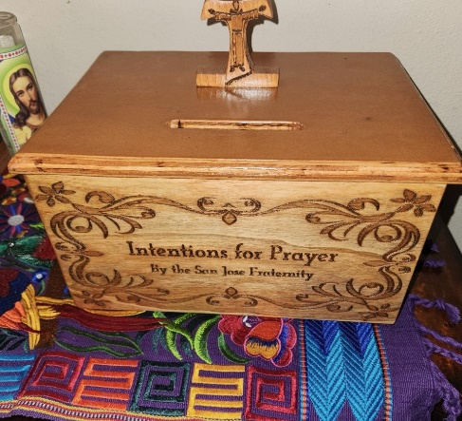

Apostolate for Food Banks: Please bring can goods (the Pop-Top kind only) to our monthly gatherings. We will collect these and distribute to one of our local parishes who have food distribution to the poor.
Apostolate for Homeless: Please bring items to pass to the homeless at the breakfast at Our Lady of Guadalupe Shrine. Needed are: SOCKS, Hats, Glover, Scarfs, small toiletry items.
Food for the Homeless: At Our Lady of Guadalupe Shrine, Br. Jaime’s Franciscan Outreach Ministry is at work every week usually in the mornings (Mon, Tues, Thru, & Fri) around 8:00am. We can try to help in the kitchen during the week to help Br. Jaime. They serve around 9:30-12. They start cooking around 8:30am.
TAU Newsletter of the National Fraternity: The NAFRA Newsletter is published 4 times per year. The Fall 2025 issue has been published. It may be found on the following Internet connection: TAU-USA Magazine – Secular Franciscan Order – USA. Look for this Tau Winter issue.
Catechism of the Catholic Church

233. Who acts in the liturgy? In the liturgy it is the whole Christ (Christus Totus) who acts, Head and Body. As our High Priest he celebrates with his body, which is the Church in heaven and on earth. Further reading: CCC 1135-1137, 1187

234. Who celebrates the heavenly liturgy? The heavenly liturgy is celebrated by the angels, by the saints of the Old and New Testament, particularly the Mother of God, by the Apostles, by the martyrs, and by the "great multitude which no one could number from every nation, race, people, and tongue." (Revelation 7:9). When we celebrate the mystery of our salvation in the sacraments we participate in this eternal liturgy.
Further reading: CCC 1138 - 1139
235. How does the Church on earth celebrate the liturgy? The Church on earth celebrates the liturgy as priestly people in which each one acts according to his proper function in the unity of the Holy Spirit. The baptized offer themselves in a spiritual sacrifice; the ordained ministers celebrate according to the Order they received for the service of all the members of the Church; the bishops and priests act in the Person of Christ the Head.
Further reading: CCC 1140-1144 , 1188

236. How is the liturgy celebrated? The celebration of the liturgy is interwoven with signs and symbols whose meaning is rooted in creation in human culture. It is determined by the events of the Old Testament and is fully revealed in the Person and work of Christ.
Further reading: CCC 1145
237. From where do the sacramental signs come? Some come from created things (light, water, fire, bread, wine, oil); others come from social life (washing, anointing, breaking of bread). Still others come from the history of salvation in the Old Covenant (the Passover rites, the sacrifices, the laying on of hands, the consecrations). These signs, some of which are normative and unchangeable, were taken up by Christ and are made the bearers of his saving and sanctifying action. Further reading: CCC 1146-1152, 1189

Pax et Bonum! Peace and All Good!! Paz y Bien!
Suzanne Salinas-Valdillez, ofs, Minister; 7710 Tourney Oak Dr. San Antonio, TX 78223

