 “Ordo Franciscanus Saecularis”
San Jose Fraternity San Antonio, Texas Secular Franciscan Order

February 2026
Fraternity Council
Minister: Suzanne Salinas-Valdillez, ofs
Vice Minister: Mary Basile, ofs
Secretary: Judith Hooge, ofs
Treasurer: George Irving, ofs
Formation Director: María de Jesús Ríos, ofs
Spiritual Assistant Friar Dennis Schafer, ofm

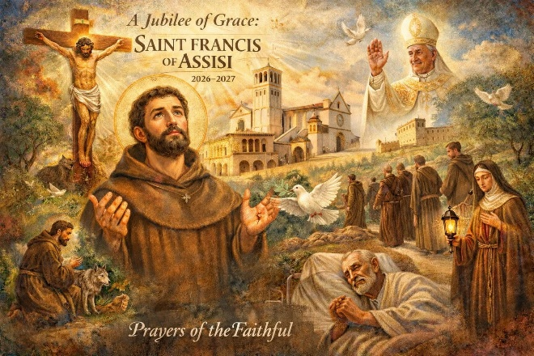

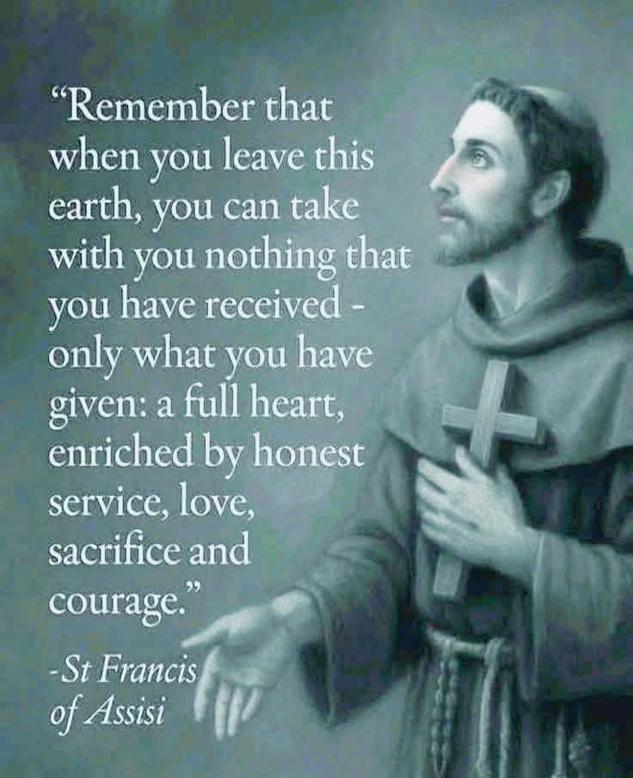

Judith Hooge, ofs will be presenting our February On-going Formation: JOURNEYING INTO LENT:
Remembering the Dignity of our Baptism and the Gifts of the Holy Spirit.

Next Fraternity Meeting: Sunday, February 15, 2026 (3rd Sunday)
St. Francis Parish Hall, San Jose Mission, San Antonio, TX

12:00-12:30PM Professed Member Arrival & Social Time – bring your food items. Please bring canned goods (the pop-top kind) for our donation to St. Vincent de Paul at one of the San Antonio Parishes. Please also bring any socks, gloves, or hats for our outreach to the homeless.
(A-J) Main Dishes
(K-Z) Side Dishes
Our February meeting will be a Mardi Gras Fat Tuesday lunch. Please bring appropriate items as a prelude to our 40 days of Lent.

12:30PM Rosary followed by Liturgy for the 6th Sunday in Ordinary Time; and Ongoing Formation

1:00PM Fraternity Social and Meeting

4:00PM Adjourn
Save the Dates:
- March 15, 2026 Fraternity Meeting, 3rd Sun, St. Francis Center @ San Jose Mission
In March we will be celebrating our 94th anniversary of Fraternity establishment (1932 at San Jose Mission) by going to Noon Mass in the Mission church as a group and then we will return to the St. Francis Center and have our social followed by a ‘mini-retreat’ given by Fr. Dennis.
- April 19, 2026 Fraternity Meeting, 3rd Sun, St. Francis Center @ San Jose Mission
- May 17, 2026 Fraternity Meeting, 3rd Sun, St. Francis Center @ San Jose Mission
- June 14, 2026 Fraternity Meeting, 2nd Sun due to Father’s day on the 3rd Sunday.

PRAYER LIST: Continued prayers for health and spiritual blessings for all our members and their family members, and most especially:

Raquel Gomez, ofs, Frances Rosales, ofs, Alice McRae, ofs, Maggie Padilla, ofs, Lois Guckian, ofs, Mary Zanyi, ofs, Petra Macias, ofs, Ana Gaus, ofs, Maria de Jesus Rios, ofs, and Maria’s niece, Lydia Ramon, ofs, Sharonann Brunet, ofs, and Mary Solomon, ofs. Let us also remember all the homeless folks in San Antonio.

FEBRUARY BIRTHDAY:
NONE
FEBRUARY PROFESSION:
NONE\

CALENDAR OF FRANCISCAN SAINTS for February - Month of the Holy Family
1. Bl. Patrick O’Loughran, Priest, religious of the Franciscan 1st Order, martyr d. 1612
2. Purification of the Blessed Virgin Mary
3. Martyrs of Japan, religious of the Franciscan 1st Order, lay brothers and Franciscan Third Order Secular, d. 1597
4. St. Joseph de Leonisse, Priest, Capuchin religious, d. 1612
5. St. Jane of Valois, Virgin, the Franciscan 2nd-Order; a "Poor Clare" sister, d. 1505
6. Bl. Pius IX, Pope, Franciscan Third Order Secular, d.1878
7. St. Egide-Marie de St. Joseph, lay brother, religious of the Franciscan 1st Order d. 1812
8. Bl. Anthony of Stroncone, lay brother, religious of the Franciscan 1st Order, d. 1461
9. Bl. Clare of Rimini, Virgin, of the Franciscan 2nd-Order; a "Poor Clare" sister, d. 1346
10. Bl. Alojzije Stepinac, Bishop, Franciscan Third Order Secular, d. 1960
11. Apparition of Our Lady of Lourdes, 1858
12. Bl. Andre Ferrari, Bishop, Franciscan Third Order Secular, d. 1921
13. St. Eustochium of Messine, Virgin, of the Franciscan 2nd-Order; a "Poor Clare" sister, d. 1485
14. Bl. Philippa Mareri, Virgin, of the Franciscan 2nd-Order; a "Poor Clare" sister, d. 1263
15. Translation of the relics of St. Anthony
16. Bl. Veridiana, Virgin, Franciscan Third Order Secular, d. 1242
17. Bl. Luke Belludi, Priest, religious of the Franciscan 1st Order, d. 1286
18. St. Bernadette Soubirous, Virgin, cordbearer, d. 1879 Plenary Indulgence possible for the Cordbearers only
19. St. Conrad de Plaisance, Confessor, Franciscan Third Order Secular, d. 1351
20. Bl. Peter of Treja, Priest religious of the Franciscan 1st Order, d. 1304
21. St. Margaret of Cortona, penitent, Franciscan Third Order Secular, d. 1297, Plenary Indulgence possible (renewal of engagements of the Franciscan Third Order Secular)
22. Feast of the Chair of St. Peter
23. Bl. Isabelle of France, Virgin of the Franciscan 2nd-Order; a "Poor Clare" sister, d. 1270
24. Bl. Innocent XI, Pope, Franciscan Third Order Secular, d. 1689
25. Bl. Sebastian of Aparicio, lay brother, religious of the Franciscan 1st Order, d. 1600
26. Bl. Antonia of Florence, Virgin, Franciscan Third Order Secular, d. 1533
27. Bl. Louise Albertoni, Virgin, Franciscan Third Order Secular, d. 1533
28. Bl. Jeremie de Valachie, lay brother, Capuchin religious, d. 1625

Prayer Apostolate: The Fraternity will be praying for those special intentions that often do not become verbalized. We placed a box in San Jose Mission Church where anyone may place a written note with the person’s name or the intention subject. The initial outpouring of prayer requests has been extraordinary. Each member present at our monthly gathering took ‘handfuls’ of prayer intentions to remember during the next month.
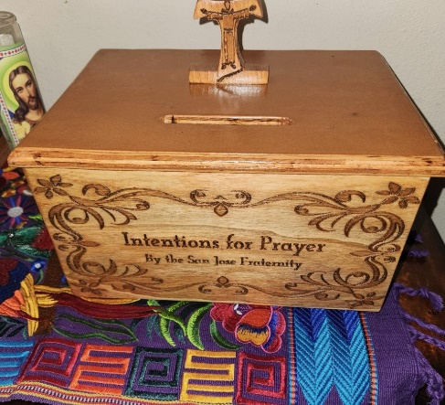

Apostolate for Food Banks: Please bring can goods (the Pop-Top kind only) to our monthly gatherings. We will collect these and distribute to one of our local parishes who have food distribution to the poor.
Apostolate for Homeless: Please bring items to pass to the homeless at the breakfast at Our Lady of Guadalupe Shrine. Needed are: SOCKS, Hats, Glover, Scarfs, small toiletry items.
Food for the Homeless: At Our Lady of Guadalupe Shrine, Br. Jaime’s Franciscan Outreach Ministry is at work every week usually in the mornings (Mon, Tues, Thru, & Fri) around 8:00am. We can try to help in the kitchen during the week to help Br. Jaime. They serve around 9:30-12. They start cooking around 8:30am.

Catechism of the Catholic Church

238. What is the link between the actions and the words in the celebration of the sacraments? Actions and words are very closely linked in the celebration of the sacraments. Indeed, even if the symbolic actions are already in themselves a language, it is necessary that the words of the rite accompany and give life to these actions. The liturgical words and actions are inseparable both insofar as they are meaningful signs and insofar as they bring about what they signify. Further reading: CCC 1153-1155, 1190
239. What are the criteria for the proper use of singing and music in liturgical celebrations? Since song and music are closely connected with liturgical action they must respect the following criteria. They should conform to Catholic doctrine in their texts, drawn preferably from Sacred Scripture and liturgical sources. They should be a beautiful expression of prayer. The music should be of a high quality. Song and music should encourage the participation of the liturgical assembly. They should express the cultural richness of the People of God and the sacred and solemn character of the celebration. "He who sings, prays twice" (Saint Augustine).
Further reading: CCC 1156-1158, 1191

240. What is the purpose of holy images? The image of Christ is the liturgical icon par excellence. Other images, representations of Our Lady and of the Saints, signify Christ who is glorified in them. They proclaim the same Gospel message that Sacred Scripture communicates by the word and they help to awaken and nourish the faith of believers.
Further reading: CCC 1159-1161, 1192
241. What is the center of the liturgical season? The center of the liturgical season is Sunday which is the foundation and kernel of the entire liturgical year and has its culmination in the annual celebration of Easter, the feast of feasts. Further reading: CCC 1163-1167, 1193

242. What is the function of the liturgical year? In the liturgical year the Church celebrates the whole mystery of Christ from his Incarnation to his return in glory. On set days the Church venerates with special love the Blessed Virgin Mary, the Mother of God. The Church also keep the memorials of saints who lived for Christ, who suffered with him, and who live with him in glory. Further reading: CCC 1168-1173, 1194-1195
243. What is the Liturgy of the Hours? The Liturgy of the Hours, which is the public and common prayer of the Church, is the prayer of Christ with his body, the Church. Through the Liturgy of the Hours the mystery of Christ, which we celebrate in the Eucharist, sanctifies and transforms the whole of each day. It is composed mainly of psalms, other biblical texts, and readings from the Fathers and spiritual masters. Further reading: CCC 1174-1178
Pax et Bonum! Peace and All Good!! Paz y Bien!
Suzanne Salinas-Valdillez, ofs, Minister; 7710 Tourney Oak Dr. San Antonio, TX 78223

