 “Ordo Franciscanus Saecularis”
San Jose Fraternity San Antonio, Texas Secular Franciscan Order

March 2026
Fraternity Council
Minister: Suzanne Salinas-Valdillez, ofs
Vice Minister: Mary Basile, ofs
Secretary: Judith Hooge, ofs
Treasurer: George Irving, ofs
Formation Director: María de Jesús Ríos, ofs
Spiritual Assistant Friar Dennis Schafer, ofm

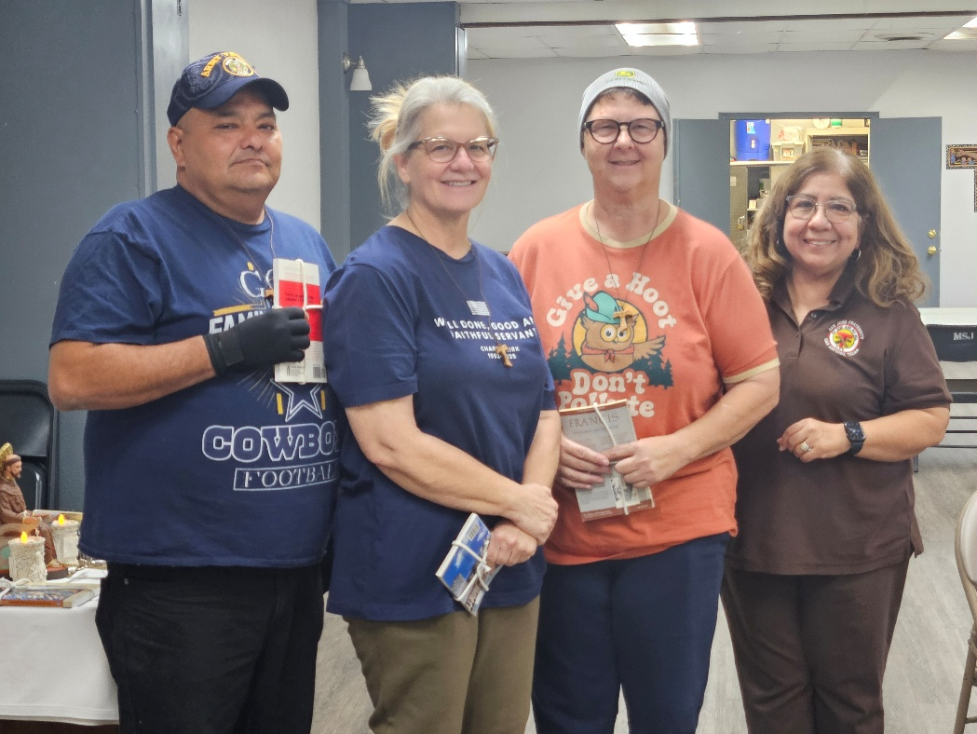
Minister Suzanne Salinas-Valdillez, ofs (above right) welcomed Manuel Garcia, Angela Hayungs, and Bridget Nicks into our San Jose Fraternity on Sunday February 15, 2026.

Next Fraternity Meeting: Sunday, March 15, 2026 (3rd Sunday)
St. Francis Parish Hall, San Jose Mission, San Antonio, TX
Please note Schedule Change for our Anniversary of Establishment

11:00-11:30PM Professed Member Arrival - bring your food items. Remember, we are in the season of Lent. Let us keep the food items simple

12:00PM Mass in the San Jose Mission Church. We will sit on the right side in front.
Transportation from St. Francis Hall to the Church will be available.

1:00PM Return to the St. Francis Parish Center - Fraternity Social & Anniversary

1:30PM Fr. Dennis will conduct a Mini-Retreat

4:00PM Adjourn
Save the Dates:
- March 15, 2026 Fraternity Meeting, 3rd Sun, St. Francis Center @ San Jose Mission
We will be celebrating our 94th anniversary of Fraternity establishment (1932 at San Jose Mission) by going to Noon Mass in the Mission church as a group and then we will return to the St. Francis Center and have our social followed by a ‘mini-retreat’ given by Fr. Dennis.
- April 19, 2026 Fraternity Meeting, 3rd Sun, St. Francis Center @ San Jose Mission
- May 17, 2026 Fraternity Meeting, 3rd Sun, St. Francis Center @ San Jose Mission
- June 14, 2026 Fraternity Meeting, 2nd Sun due to Father’s Day on the 3rd Sunday.

PRAYER LIST: Continued prayers for health and spiritual blessings for all our members and their family members, and most especially:

Raquel Gomez, ofs, Frances Rosales, ofs, Alice McRae, ofs, Maggie Padilla, ofs, Lois Guckian, ofs, Mary Zanyi, ofs, Petra Macias, ofs, Ana Gaus, ofs, Maria de Jesus Rios, ofs, and Maria’s niece, Lydia Ramon, ofs, Sharonann Brunet, ofs, and Mary Solomon, ofs. Let us also remember all the homeless folks in San Antonio.

MARCH BIRTHDAY: ¡¡Feliz Cumpleaños!!
Ana Gaus – March 12th
Sharonanne Brunet, March 16th

MARCH PROFESSION:
Alice McRae – March 21st, 1999
Margie Gonzalez – March 24th, 1991

CALENDAR OF FRANCISCAN SAINTS for March - Month of the St. Joseph
1. Bl. Jean Kearney, Priest, religious of the Franciscan 1st Order, martyr 1653
2. St. Agnes de Prague, Virgin, of the Franciscan 2nd-Order; a "Poor Clare" sister, d. 1282
3. Bl. Innocent of Berzo, Priest, Capuchin, d. 1890
4. Bl. Martyrs of the Franciscan 1st Order of Gondar (Ethiopia), d. 1716
5. St. John-Joseph of the Cross, Priest, religious of the Franciscan 1st Order, d. 1734
6. St. Colette de Corbie, Virgin, of the Franciscan 2nd-Order; a "Poor Clare" sister, d. 1447
7. Bl. Christopher of Milan, Priest, religious of the Franciscan 1st Order, d. 1485
8. St. Jean de Dieu, Priest, had been a tertiary before founding or joining another religious Institute, d. 1550
9. St. Frances of Rome, Virgin, had been a tertiary before founding or joining another religious Institute, d. 1440
10. St. Catherine of Bologne, Virgin of the Franciscan 2nd-Order; a "Poor Clare" sister, d. 1463
11. Bl. John Baptist Righi of Fabriano, Priest, religious of the Franciscan 1st Order, d. 1539
12. Bl. Louis Orione, Priest, Franciscan Third Order Secular, d. 1940
13. Bl. Agnellus of Pisa, Priest, religious of the Franciscan 1st Order, d. 1236
14. St. Catherine of Genoa, Virgin, Franciscan Third Order Secular, d. 1510
15. Bl. Louis of Casoria, Priest, religious of the Franciscan 1st Order, d. 1885
16. Bl. Torello of Poppi, Confessor, Franciscan Third Order Secular, d. 1282
17. Bl. Mark of Montegallo, Priest, religious of the Franciscan 1st Order, d. 1496
18. St. Salvator of Horta, lay brother, religious of the Franciscan 1st Order, d. 1567
19. Saint Joseph,
20. Bl. Hippolyte Galentini, Confessor, Franciscan Third Order Secular, d. 1620
21. Bl Amedee IX de Savoie, Confessor, Franciscan Third Order Secular, d. 1472
22. St. Benvenute of Osimo, Bishop, religious of the Franciscan 1st Order, d. 1282
23. Bl. Jeremy Lambertenghi, Priest, Franciscan Third Order Secular, d. 1513
24. Bl. Catherine de Suede, Virgin, had been a tertiary before founding or joining another religious Institute, d. 1381
25. Feast of the Annunciation of the Blessed Virgin Mary, Holy Day of Obligation for the Church
26. Blessed Didacus Joseph of Cadiz, Priest, Capuchin, d. 1801
27. Bl. Joseph-Sebastien Pelczar, Bishop, Franciscan Third Order Secular, d. 1924..
28. St. John of Capistrano, Priest, religious of the Franciscan 1st Order, d. 1456
29. Bl. Jane Mary of Maille, Virgin, Franciscan Third Order Secular, d. 1414
30. St. Peter Regalado, Priest, religious of the Franciscan 1st Order, d. 1486
31. St. Leonard Murialdo, Priest, Franciscan Third Order Secular, d. 1900

Prayer Apostolate: The Fraternity will be praying for those special intentions that often do not become verbalized. We placed a box in San Jose Mission Church where anyone may place a written note with the person’s name or the intention subject. The outpouring of prayer requests has been extraordinary. Each member present at our monthly gathering took ‘handfuls’ of prayer intentions to remember during the next month.
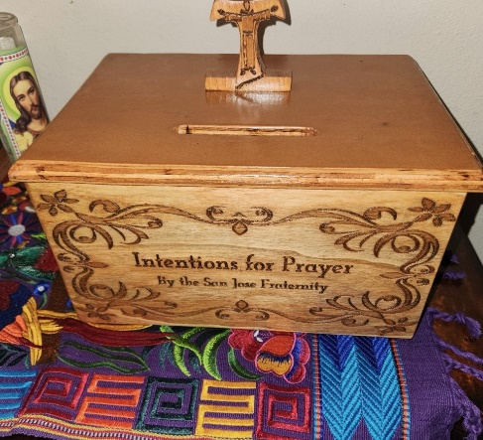

Apostolate for Food Banks: Please bring can goods (the Pop-Top kind only) to our monthly gatherings. We will collect these and distribute to one of our local parishes who have food distribution to the poor.
Apostolate for Homeless: Please bring items to pass to the homeless at the breakfast at Our Lady of Guadalupe Shrine. Needed are: SOCKS, Hats, Glover, Scarfs, small toiletry items.
Food for the Homeless: At Our Lady of Guadalupe Shrine, Br. Jaime’s Franciscan Outreach Ministry is at work every week usually in the mornings (Mon, Tues, Thru, & Fri) around 8:00am. We can try to help in the kitchen during the week to help Br. Jaime. They serve around 9:30-12. They start cooking around 8:30am.
Catechism of the Catholic Church

244. Does the Church need places in order to celebrate the liturgy? The worship "in spirit and truth" (John 4:24) of the New Covenant is not tied exclusively to any place because Christ is the true temple of God. Through him Christians and the whole Church become temples of the living God by the action of the Holy Spirit. Nonetheless, the people of God in their earthly condition need places in which the community can gather to celebrate the liturgy. Further reading: CCC 1179-1181
245. What are sacred buildings? They are the houses of God, a symbol of the Church that lives in that place as well as of the heavenly Jerusalem. Above all they are places of prayer in which the Church celebrates the Eucharist and worships Christ who is truly present in the tabernacle. Further reading: CCC 1181, 1198 - 1199

246. What are the privileged places inside sacred buildings? They are: the altar, the tabernacle, the place where the sacred Chrism and other holy oils are kept, the chair of the bishop (cathedra) or the chair of the priest, the ambo, the baptismal font, and the confessional. Further reading: CCC 1182-1186

247. Why is the one Mystery of Christ celebrated by the Church according to various liturgical traditions? The answer is that the unfathomable richness of the mystery of Christ cannot be exhausted by any single liturgical tradition. From the very beginning, therefore, this richness found expression among various peoples and cultures in ways that are characterized by a wonderful diversity and complementarily.
Further reading: CCC 1200-1204,1207-1209
248. What is the criterion that assures unity in the midst of plurality? It is fidelity to the Apostolic Tradition, that is, the communion of the faith and in the sacraments received from the apostles, a communion that is both signified and guaranteed by apostolic succession. The Church is Catholic and therefore can integrate into her unity all the authentic riches of cultures. Further reading: CCC 1209
249. Is everything immutable in the liturgy? In the liturgy, particularly in that of the sacraments, there are unchangeable elements because they are of divine institution. The Church is the faithful guardian of them. There are also, however, elements subject to change which the Church has the power and on occasion also the duty to adapt to the cultures of diverse peoples. Further reading: CCC 1205-1206
Pax et Bonum! Peace and All Good!! Paz y Bien!
Suzanne Salinas-Valdillez, ofs, Minister; 7710 Tourney Oak Dr. San Antonio, TX 78223

