 “Ordo Franciscanus Saecularis”
San Jose Fraternity San Antonio, Texas Secular Franciscan Order

May 2026
Fraternity Council
Minister: Suzanne Salinas-Valdillez, ofs
Vice Minister: Mary Basile, ofs
Secretary: Judith Hooge, ofs
Treasurer: George Irving, ofs
Formation Director: María de Jesús Ríos, ofs
Spiritual Assistant Friar Dennis Schafer, ofm

San Jose Fraternity Minister (Right), Suzanne Salinas-Valdillez, ofs, welcomes, Angela Garcia into our initial formation at our April 2026 Fraternity Gathering.
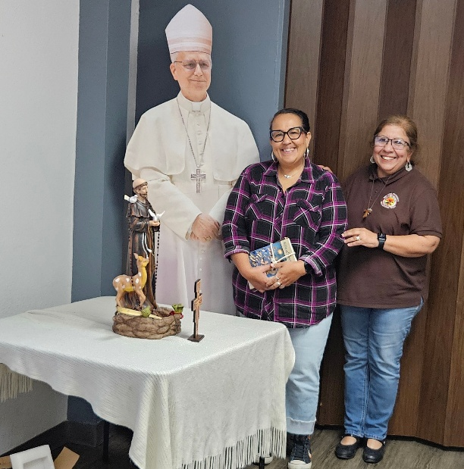

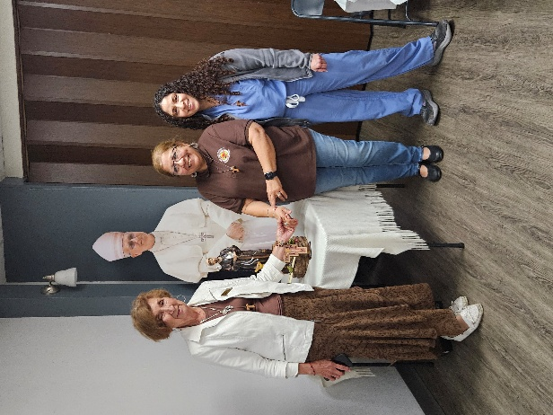
San Jose Fraternity Minister (Center), Suzanne Salinas-Valdillez, ofs, performed the Ceremony of Reception for Lupita Lopez, and Maui Martinez during our April 2006 Fraternity Gathering.

Next Fraternity Meeting: Sunday, May 17, 2026 (3rd Sunday)
St. Francis Parish Hall, San Jose Mission, San Antonio, TX

12:00-12:30PM Professed Member Arrival & Social Time – bring your food items. Please bring canned goods (the pop-top kind) for our donation to St. Vincent de Paul at one of the San Antonio Parishes. Please also bring any socks, gloves, or hats for our outreach to the homeless.
(A-J) Side Dishes
(K-Z) Main Dishes

12:30PM Rosary followed by Liturgy for the 7th Sunday in Easter; and Ongoing Formation
We will be having a Diaper Drive for the ladies at Seton Home. Please bring Diapers, sizes 5, 6, and 7; and pull-ups size 4-5T; and Wet Wipes – non-Scented.

1:00PM Fraternity Social and Meeting

4:00PM Adjourn
Save the Dates:
- May 17, 2026, Fraternity Meeting, 3rd Sun, St. Francis Center @ San Jose Mission
- June 14, 2026, Fraternity Meeting, 2nd Sun due to Father’s Day on the 3rd Sunday.
- July 19, 2026, Fraternity Meeting, 3rd Sun, St. Francis Center @ San Jose Mission.

PRAYER LIST: Continued prayers for health and spiritual blessings for all our members and their family members, and most especially:

Raquel Gomez, ofs, Frances Rosales, ofs, Alice McRae, ofs, Maggie Padilla, ofs, Lois Guckian, ofs, Mary Zanyi, ofs, Petra Macias, ofs, Ana Gaus, ofs, Maria de Jesus Rios, ofs, and Maria’s niece, Lydia Ramon, ofs, Sharonann Brunet, ofs, and Mary Solomon, ofs. Let us also remember all the homeless folks in San Antonio.

Pray for the intention of the Holy Father for May: that everyone might have food.

MAY BIRTHDAY: Feliz Cumpleaños!!
Lydia Ramon, ofs May 16th

MAY PROFESSION:
Flo Sepulveda, ofs May 19th

CALENDAR OF FRANCISCAN SAINTS for May - Month of Holy Virgin Mary
1. Feast of Saint Joseph the Artisan
2. St. Richard Pampuri, Confessor, had been a tertiary before founding or joining another religious Institute, d. 1930
3. Bl. Edouard-Joseph Rosas, Bishop, Franciscan Third Order Secular, d. 1903
4. Bl. Ladislas de Gielniow, Priest, religious of the Franciscan 1st Order, d. 1505
5. Bl. Beinvenu Mareni, lay brother, religious of the Franciscan 1st Order, d. 1289
6. Bl. Marie-Catherine Troijani, Virgin, religious of the Third-Order Regular [living in community, under a Rule], d. 1897
7. Bl. Anne-Rose Gattorno, Virgin, religious of the Third-Order Regular [living in community, under a Rule], d. 1900
8. Feast of Mary Mediatrix of all Graces
9. Bl. Antoine Bajewski, Priest, Conventual religious, martyr 1941
10. Bl. Marie-Bernard Butler, Virgin, religious of the Third-Order Regular [living in community, under a Rule], d. 1924
11. St. Gemme de Sulmona, Virgin, Franciscan Third Order Secular, d. 1439
12. St Ignatius of Laconi, lay brother, Capuchin religious, d. 1781
13. St. Michael Garicoits, Priest, had been a tertiary before founding or joining another religious Institute, d. 1863
14. St. Marie-Dominique Mazzarello, Virgin, had been a tertiary before founding or joining another religious Institute, d. 1881
15. St. Jean-Baptiste de la Salle, Priest, had been a tertiary before founding or joining another religious Institute, d. 1719
16. St. Theophilus of Corte, Priest, religious of the Franciscan 1st Order, d. 1740
17. St. Paschal of Baylon, lay brother, religious of the Franciscan 1st Order, d. 1592
18. St. Felix de Cantalice, lay brother, Capuchin religious, 1587
19. St. Yves, Priest, Franciscan Third Order Secular, d. 1303
20. St. Bernardine of Siena, Priest, religious of the Franciscan 1st Order, d. 1444
21. St. Crispin of Viterbo, lay brother, Capuchin religious, d. 1750
22. St. Joaquina Vedruna, Virgin, had been a tertiary before founding or joining another religious Institute, d. 1854
23. Bl. Gerard of Villamagna, Confessor, Franciscan Third Order Secular, d. 1242
24. Bl. John of Prado, Priest, religious of the Franciscan 1st Order, martyr 1631
25. Dedication of the Basilica in Assisi, 1253
26. St. Philippe Neri, Priest, had been a tertiary before founding or joining another religious Institute, d. 1595; memorial of St Mariane of Jesus Parades, Virgin, Franciscan Third Order Secular, d. 1645
27. Bl. Gerard of Lunel, Confessor, Franciscan Third Order Secular, d. 1270
28. St. Jean-Baptiste Rossi, Priest, Franciscan Third Order Secular, d. 1764
29. Bl. Etienne et Raymond, Priest, religious of the Franciscan 1st Order, d. 1242
30. St. Joan of Arc, Virgin, Franciscan Third Order Secular, d. 1431 King Saint Fernando III, Confessor, Franciscan Third Order Secular, d. 1252
31. Feast of the Queenship of Mary, Public Consecration of the world to the Immaculate Heart of Mary Novena in preparation of the feast of Pentecost Pentecost - Plenary Indulgence – Chant in public the Veni Creator Sacred Heart – Plenary Indulgence - Public recitation of the Act of Reparation

Prayer Apostolate: The Fraternity will be praying for those special intentions that often do not become verbalized. We placed a box in San Jose Mission Church where anyone may place a written note with the person’s name or the intention subject. The outpouring of prayer requests has been extraordinary. Each member present at our monthly gathering took ‘handfuls’ of prayer intentions to remember during the next month.
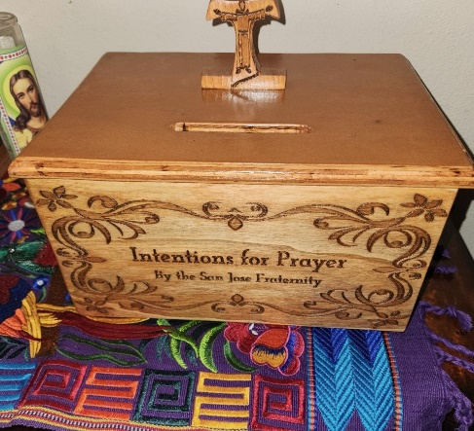

Apostolate for Food Banks: Please bring can goods (the Pop-Top kind only) to our monthly gatherings. We will collect these and distribute to one of our local parishes who have food distribution to the poor.
Apostolate for Homeless: Please bring items to pass to the homeless at the breakfast at Our Lady of Guadalupe Shrine. Needed are: SOCKS, Hats, Glover, Scarfs, small toiletry items.
Food for the Homeless: At Our Lady of Guadalupe Shrine, Br. Jaime’s Franciscan Outreach Ministry is at work every week usually in the mornings (Mon, Tues, Thru, & Fri) around 8:00am. We can try to help in the kitchen during the week to help Br. Jaime. They serve around 9:30-12. They start cooking around 8:30am.
Catechism of the Catholic Church
257. Who can receive Baptism?
Every person not yet baptized is able to receive Baptism. Further reading: CCC 1246-1252
258. Why does the Church baptize infants? The church baptizes infants because they are born with original sin. They need to be freed from the power of the Evil One and brought into the realm of freedom which belongs to the children of God. Further reading: CCC 1250
259. What is required of one who is to be baptized? Everyone who is to be baptized is required to make a profession of faith. This is done personally in the case of an adult or by the parents and by the Church in the case of infants. Also the godfather or the godmother and the whole ecclesial community share the responsibility for baptismal preparation (catechumenate) as well as for the development and safeguarding of the faith and grace given at baptism. Further reading: CCC 1253-1255

260. Who can baptize? The ordinary ministers of Baptism are the bishop and the priest. In the Latin Church the deacon also can baptize. In case of necessity any person can baptize provided he has the intention of doing what the Church does. This is done by pouring water on the head of the candidate while saying the Trinitarian formula for Baptism: "I baptize you in the name of the Father and the Son and of the Holy Spirit." Further reading: CCC 1256, 1284
261. Is Baptism necessary for salvation? Baptism is necessary for salvation for all those to whom the Gospel has been proclaimed and who have had the possibility of asking for this sacrament. Further reading: CCC 1257

262. Is it possible to be saved without Baptism? Since Christ died for the salvation of all, those can be saved without Baptism who die for the faith (Baptism of blood). Catechumens and all those who, even without knowing Christ and the Church, still (under the impulse of grace) sincerely seek God and strive to do His will can also be saved without Baptism (Baptism of desire). The Church in her liturgy entrusts children who die without Baptism to the mercy of God. Further reading: CCC 1258-1261, 1281-1283

263. What are the effects of Baptism? Baptism takes away original sin, all personal sins and all punishment due to sin. It makes the baptized person a participant in the divine life of the Trinity through sanctifying grace, the grace of justification which incorporates one into Christ and into his Church. It gives one a share in the priesthood of Christ and provides the basis for communion with all Christians. It bestows the theological virtues and the gifts of the Holy Spirit. A baptized person belongs forever to Christ. He is marked with the indelible seal of Christ (character). Further reading: CCC 1262-1274, 1279-1280
Pax et Bonum! Peace and All Good!! Paz y Bien!
Suzanne Salinas-Valdillez, ofs, Minister; 7710 Tourney Oak Dr. San Antonio, TX 78223

