 “Ordo Franciscanus Saecularis”
San Jose Fraternity San Antonio, Texas Secular Franciscan Order

June 2026
Fraternity Council
Minister: Suzanne Salinas-Valdillez, ofs
Vice Minister: Mary Basile, ofs
Secretary: Judith Hooge, ofs
Treasurer: George Irving, ofs
Formation Director: María de Jesús Ríos, ofs
Spiritual Assistant Friar Dennis Schafer, ofm

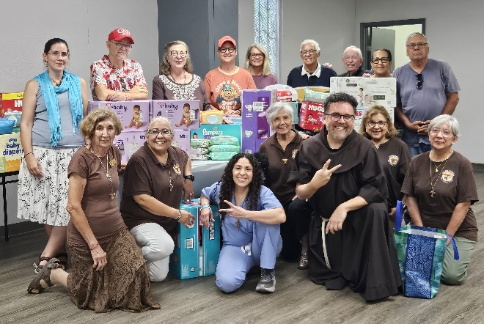
San Jose Fraternity conducted a Diaper drive for the ladies & their children at the Seton Home during our May 2026 Fraternity gathering.

Flo Sepulveda, ofs & Minister Suzanne Salinas-Valdillez, ofs deliver diapers to a staff member of the Seton Home.

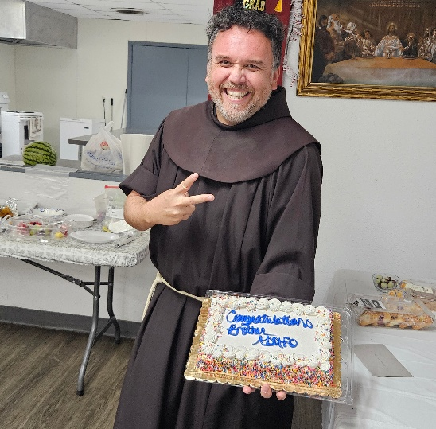
Bro Adolfo, OFM, celebrated the completion of his studies at Oblate with a cake, an autographed stuffed animal from the Fraternity and a gorgeous poodle.
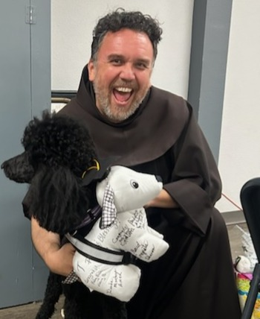

Next Fraternity Meeting: Sunday, June 14, 2026 (2nd Sunday)
St. Francis Parish Hall, San Jose Mission, San Antonio, TX

12:00-12:30PM Professed Member Arrival & Social Time – bring your food items. Please bring canned goods (the pop-top kind) for our donation to St. Vincent de Paul at one of the San Antonio Parishes. Please also bring any socks, gloves, or hats for our outreach to the homeless.
(A-J) Main Dishes
(K-Z) Side Dishes

12:30PM Liturgy of the Hours for the 11th Sunday in Ordinary Time followed by Ongoing Formation

1:00PM Fraternity Social and Meeting

4:00PM Adjourn
Save the Dates:
- May 29-31, 2026, Fraternity Council Retreat
- June 2, 2026: Services for our Fraternity member Maggie Padilla, ofs at;
10:30 am Joan of Arc Catholic church, 2829 Ackerman Rd., 78210
Reception to follow and Internment at Sunset Memorial Park, 1701 Austin Hwy.
- June 14, 2026, Fraternity Meeting, 2nd Sun due to Father’s Day on the 3rd Sunday.
- July 19, 2026, Fraternity Meeting, 3rd Sun, St. Francis Center @ San Jose Mission.
- August 16, 2026, Fraternity Meeting, 3rd Sun, St. Francis Center @ San Jose Mission

PRAYER LIST: Continued prayers for health and spiritual blessings for all our members and their family members, and most especially:

Raquel Gomez, ofs, Frances Rosales, ofs, Alice McRae, ofs, Lois Guckian, ofs, Mary Zanyi, ofs, Petra Macias, ofs, Ana Gaus, ofs, Maria de Jesus Rios, ofs, and Maria’s niece, Lydia Ramon, ofs, Sharonann Brunet, ofs, and Mary Solomon, ofs. Let us also remember all the homeless folks in San Antonio.

Pray for the intention of the Holy Father for June: For the values of sports.

JUNE BIRTHDAY: Feliz Cumpleaños!!
Margarita Gonzalez ofs, June 5

JUNE PROFESSION:
Judith Hooge, ofs June 14, 2009

CALENDAR OF FRANCISCAN SAINTS for June - Month of the Sacred Heart of Jesus
1. Bl. Felix of Nicosia, lay brother, Capuchin religious. d/ 1787
2. Bl. John Pelingotto, Confessor, Franciscan Third Order Secular, d. 1304
3. Bl. Andrew of Spello, Priest, religious of the Franciscan 1st Order, d. 1254
4. St. Francois Caracciolo, Priest, had been a tertiary before founding or joining another religious Institute, d. 1608
5. Bl Pacific of Cerano, Priest, religious of the Franciscan 1st Order, d. 1482
6. Bl. Lawrence of Villamagna, Priest, religious of the Franciscan 1st Order, d. 1535
7. Bl. Himiliana Cerchi, Virgin, Franciscan Third Order Secular, d. 1246
8. Bl. Nicolas de Gesturi, lay brother, Capuchin religious, d. 1958
9. Bl. Innocent Guz, Priest, Conventual religious, martyr 1940
10. Bl. Edouard Poppe, Priest, Franciscan Third Order Secular, d. 1924
11. Bl. Yolanda of Hungary, Virgin, of the Franciscan 2nd-Order; a "Poor Clare" sister, d. 1298
12. Bl. Floride Cevoli, Virgin, Capuchin religious, d. 1767
13. St. Anthony of Padua, Priest, religious of the Franciscan 1st Order, d. 1231 Plenary Indulgence for cordbearers
14. Bl. Zephirin Jimenez, Martyr, Franciscan Third Order Secular, d. 1936
15. St. Vincenta Gerosa, Virgin, had been a tertiary before founding or joining another religious Institute, d. 1847, and Saint Mary Bartholomea Capitanio.
16. Bl. Marie-Therese Scherer, Virgin, had been a tertiary before founding or joining another religious Institute, d. 1888
17. Bl. Peter Gambacorti, Confessor, Franciscan Third Order Secular, d. 1435
18. Bl. Guy of Cortona, Priest, religious of the Franciscan 1st Order, d. 1250
19. Bl. Achille Puchata, Priest, Conventual religious, martyr 1943
20. Bl. Micheline de Pesaro, Virgin, Franciscan Third Order Secular, d. 1356
21. Bl. Herman Stapien, Priest, Conventual religious, martyr 1943
22. St. Thomas More, Martyr, Franciscan Third Order Secular, d. 1943
23. St. Joseph Cafasso, Priest, Franciscan Third Order Secular, d. 1860
24. Nativity of St. John the Baptist
25. Bl. Bienvenu de Gubbio, lay brother, religious of the Franciscan 1st Order, d. 1232
26. Bl. Frederick Jassoone, Priest, religious of the Franciscan 1st Order, d. 1916
27. Bl. Marguerite Baeys, Virgin, Franciscan Third Order Secular, d. 1879
28. St. Barthelemie Capitanio, Virgin, had been a tertiary before founding or joining another religious Institute, d. 1833
29. Sts. Peter and Paul, Holy Day of Obligation, Plenary Indulgence
30. Bl. Raymond Lulle, Martyr, Franciscan Third Order Secular, d. 1315

Prayer Apostolate: The Fraternity will be praying for those special intentions that often do not become verbalized. We placed a box in San Jose Mission Church where anyone may place a written note with the person’s name or the intention subject. The outpouring of prayer requests has been extraordinary. Each member present at our monthly gathering took ‘handfuls’ of prayer intentions to remember during the next month.
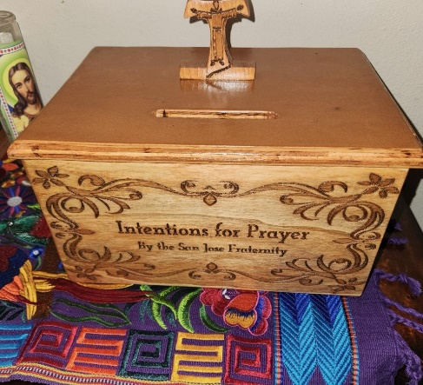

Apostolate for Food Banks: Please bring can goods (the Pop-Top kind only) to our monthly gatherings. We will collect these and distribute to one of our local parishes who have food distribution to the poor.
Apostolate for Homeless: Please bring items to pass to the homeless at the breakfast at Our Lady of Guadalupe Shrine. Needed are: SOCKS, Hats, Glover, Scarfs, small toiletry items.
Food for the Homeless: At Our Lady of Guadalupe Shrine, Br. Jaime’s Franciscan Outreach Ministry is at work every week usually in the mornings (Mon, Tues, Thru, & Fri) around 8:00am. We can try to help in the kitchen during the week to help Br. Jaime. They serve around 9:30-12. They start cooking around 8:30am.
Catechism of the Catholic Church
264. What is the meaning of the Christian name received at Baptism? The name is important because God knows each of us by name, that is, in our uniqueness as persons. In Baptism a Christian receives his or her own name in the Church. It should preferably be the name of a saint who might offer the baptized a model of sanctity and an assurance of his or her intercession before God. Further reading: CCC 2156-2159, 2167

265. What place does Confirmation have in the divine plan of salvation? In the Old Testament the prophets announced that the Spirit of the Lord would rest on the awaited Messiah and on the entire messianic people. The whole life and mission of Jesus were carried out in total communion with the Holy Spirit. The apostles received the Holy Spirit at Pentecost and proclaimed "the great works of God" (Acts 2:11). They gave the gift of the same Spirit to the newly baptized by the laying on of hands. Down through the centuries, the Church has continued to live by the Spirit and to impart him to her children. Further reading: CCC 1285-1288, 1315
266. Why is this sacrament called Chrismation or Confirmation? It is called Chrismation (in the Eastern Churches: Anointing with holy myron or chrism) because the essential rite of the sacrament is anointing with chrism. It is called Confirmation because it confirms and strengthens baptismal grace. Further reading: CCC 1289

267. What is the essential rite of Confirmation? The essential rite of Confirmation is the anointing with Sacred Chrism (oil mixed with balsam and consecrated by the bishop), which is done by the laying on of the hand of the minister who pronounces the sacramental words proper to the rite. In the West this anointing is done on the forehead of the baptized with the words, "Be sealed with the gift of the Holy Spirit". In the Eastern Churches of the Byzantine rite this anointing is also done on other parts of the body with the words, "The seal of the gift of the Holy Spirit". Further reading: CCC 1290-1301, 1318, 1320-1321
268. What is the effect of Confirmation? The effect of Confirmation is a special outpouring of the Holy Spirit like that of Pentecost. This outpouring impresses on the soul an indelible character and produces a growth in the grace of Baptism. It roots the recipient more deeply in divine sonship, binds him more firmly to Christ and to the Church and reinvigorates the gifts of the Holy Spirit in his soul. It gives a special strength to witness to the Christian faith.
Further reading: CCC 1302-1305, 1316-1317
Pax et Bonum! Peace and All Good!! Paz y Bien!
Suzanne Salinas-Valdillez, ofs, Minister; 7710 Tourney Oak Dr. San Antonio, TX 78223

