 “Ordo Franciscanus Saecularis”
San Jose Fraternity San Antonio, Texas Secular Franciscan Order

September 2025
Fraternity Council
Minister: Suzanne Salinas-Valdillez, ofs
Vice Minister: Mary Basile, ofs
Secretary: Judith Hooge, ofs
Treasurer: George Irving, ofs
Formation Director: María de Jesús Ríos, ofs
Spiritual Assistant Friar Dennis Schafer, ofm

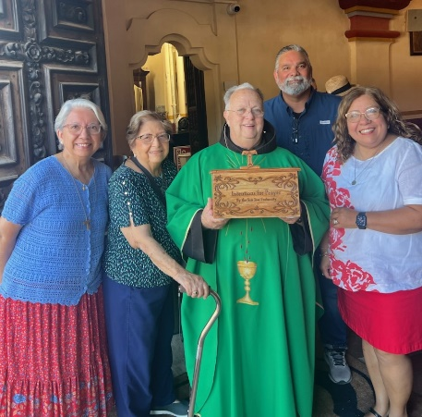
Friar Herb Joes, OFM, holds the new San Jose Fraternity Prayer Intentions box. He is accompanied by Yolanda Montoya, ofs, Alice McRae, ofs, and Suzanne Salinas-Valdillez, ofs. Mr. Clerance Lewis, pictured in the back row is the designer and builder of the Prayer Intentions Box (See page 3 for more of the story)

Next Fraternity Meeting: Sunday, September 21, 2025 (3rd Sunday)
St. Francis Parish Hall, San Jose Mission, San Antonio, TX

12:00-12:30PM Professed Member Arrival & Social Time – bring your food items. Please bring canned goods (the pop-top kind) for our donation to St. Vincent de Paul at one of the San Antonio Parishes. Please also bring any socks, gloves, or hats for our outreach to the homeless.
(A-J) Main Dishes
(K-Z) Side Dishes

12:30PM Rosary followed by Liturgy of the Hours - 25th Sunday in Ordinary Time

1:00PM Fraternity Social and Meeting

4:00PM Adjourn
Save the Dates:
- September 17, 2025, Feast of the Stigmata of St. Francis of Assisi
- Sept 21, 2025, Fraternity Meeting, 3rd Sun, St. Francis Parish Center @ San Jose
- October 3, 2025, Transitus of St. Francis, location to be announced.
- October 11, 2025, Fiesta Franciscana, St. Francis Parish Center @ San Jos –8am-4pm
- October 19, 2025 Fraternity Meeting, 3rd Sun, St. Francis Center @ San Jose Mission
- November 16, 2025, Fraternity Meeting, 3rd Sun, St. Francis Center @ San Jose Mission

PRAYER LIST: Continued prayers for health and spiritual blessings for all our members and their family members, and most especially:
The repose of the soul of Gino Macias, ofs, on 2 August 2025. Gino was a professed member of our Fraternity. He would have celebrated 50 years as a Professed Secular Franciscan in October 2025. San Jose Fraternity offers our prayers and condolences to his family.

Maggie Padilla, ofs, Lois Guckian, ofs, Mary Zanyi, ofs, Petra Macias, ofs, Raquel Gomez, ofs, Ana Gaus, ofs, Maria de Jesus Rios, ofs, and Maria’s niece, Frances Rosales, ofs, Lydia Ramon, ofs, and Mary Solomon, ofs.

SEPTENBER BIRTHDAY: Feliz Cumpleaños!! None

SEPTEMBER PROFESSION:
Maria de Jesus Rios ofs, Sept 16, 2007
Frances Rosales ofs, Sept 16, 2007

CALENDAR OF FRANCISCAN SAINTS for September – Month of the Holy Cross
1. Bl Joachim de Albocacer, Priest, Capuchin religious, martyr 1936
2. Bl. Martyrs de Carmes, d. 1792
3. St. Pius X, Pope, Franciscan Third Order Secular, d. 1914
4. St. Rose of Viterbo, Virgin, Franciscan Third Order Secular, d. 1252 Plenary Indulgence for cordbearers
5. Bl. Gentil de Matelica, Priest, religious of the Franciscan 1st Order, martyr 1340
6. Bl. Liberatus of Lauro, Priest, religious of the Franciscan 1st Order, d. 1258
7. Bl. Eugenie Picco, Virgin, religious of the Third-Order Regular [living in community, under a Rule], d. 1921
8. Nativity of the Blessed Virgin Mary
9. Bl. Seraphina Sforza, Virgin, of the Franciscan 2nd-Order; a "Poor Clare" sister, d. 1478
10. Bl. Martyrs of Japan, religious of the Franciscan 1st Order and Franciscan Third Order Seculars, d. 1622-1632
11. Bl. Bonaventure of Barcelona, lay brother, religious of the Franciscan 1st Order, d. 1684
12. Feast of the Name of Holy Mary
13. Bl. Apollinaire Franco, Priest, religious of the Franciscan 1st Order, martyr 1622
14. Exaltation of the Holy Cross
15. Feast of Our Lady of the Seven Sorrows
16. Bl. Roland de Medicis, Confessor, Franciscan Third Order Secular, d. 1386
17. Feast of the Stigmatization of St. Francis of Assisi
18. St. Joseph de Cupertino, Priest, Conventual, d. 1664
19. Bl. Louis Alleman, Bishop, Franciscan Third Order Secular, d. 1450
20. St. Francis Mary of Camporosso, lay brother, Capuchin religious, d. 1866
21. Bl. Elizabeth Amodei, Virgin, Franciscan Third Order Secular, d. 1498
22. St. Ignatius of Santhia, Priest, Capuchin religious, d. 1773
23. St. Pio of Peitrelcina, Priest, Capuchin religious, d. 1968
24. St. Pacific of San Severino, Priest, religious of the Franciscan 1st Order, d. 1721
25. St. Nicholas de Flue, Confessor, Franciscan Third Order Secular, d. 1487
26. Bl. Lucy of Caltagirone, Virgin, religious of the Third-Order Regular [living in community, under a Rule], d. 1400
27. St. Elzear of Sabran, Confessor, Franciscan Third Order Secular, d. 1323
28. Bl Bernadin of Feltre, Priest, religious of the Franciscan 1st Order, d. 1494
29. Feast of Saint Michael the Archangel
30. Bl. Charles of Blois, Confessor, Franciscan Third Order Secular, d. 1364

Apostolate for Food Banks: Please bring can goods (the Pop-Top kind only) to our monthly gatherings. We will collect these and distribute to one of our local parishes who have food distribution to the poor.
Apostolate for Homeless: Please bring items to pass to the homeless at the breakfast at Our Lady of Guadalupe Shrine. Needed are: SOCKS, Hats, Glover, Scarfs, small toiletry items
Another Apostolate: At Our Lady of Guadalupe Shrine, Br. Jaime’s Franciscan Outreach Ministry is at work every week usually in the mornings (Mon, Tues, Thru, & Fri) around 8:00am. We can try to help in the kitchen during the week to help Br. Jaime. They serve around 9:30-12. They start cooking around 8:30am.

A New Apostolate: The Fraternity will be praying for those special people or intentions that often do not become verbalized. We are placing a box somewhere in San Jose Mission Church where anyone may place a written note with the person’s name or the intention subject. Our Fraternity would then pray for that special intention. This idea originated with our Fraternity Council and was brought to fruition by the woodworking skills of Mr. Clerance Lewis
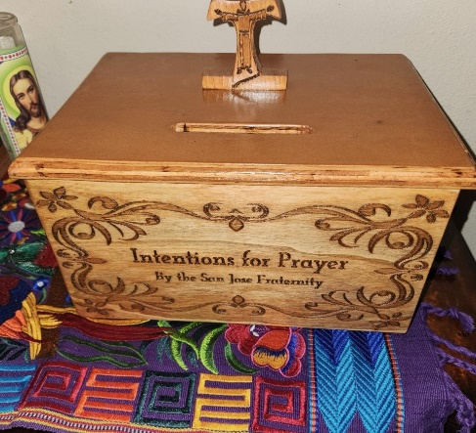

TAU Newsletter of the National Fraternity: The NAFRA Newsletter is published 4 times per year. The Summer 2025 issue was distributed to members attending the August San Jose Fraternity Gathering. It may be found on the following Internet connection: TAU-USA Magazine – Secular Franciscan Order – USA. Look for this Newsletter’s Fall issue.
Catechism of the Catholic Church

212. In what does hell consist? Hell consists in the eternal damnation of those who die in mortal sin through their own free choice. The principal suffering of hell is eternal separation from God in whom alone we can have the life and happiness for which we were created and for which we long. Christ proclaimed this reality with the words, "Depart from me, you cursed, into the eternal fire" (Matthew 25:41). Further reading: CCC 1033-1035, 1056- 1057
213. How can one reconcile the existence of hell with the infinite goodness of God? God, while desiring "all to come to repentance" (2 Peter 3:9), nevertheless has created the human person to be free and responsible; and he respects our decisions. Therefore, it is the human person who freely excludes himself from communion with God if at the moment of death he persists in mortal sin and refuses the merciful love of God. Further reading: CCC 1036-1037

214. In what does the final judgment consist? The final or universal judgment consists in a sentence of happiness or eternal condemnation, which the Lord Jesus will issue in regard to the "just and the unjust" (Acts 24:15) when he returns as the Judge of the living and the dead. After the last judgment, the resurrected body will share in the retribution which the soul received at the particular judgment. Further reading: CCC 1038-1041, 1058-1059
215. When will this judgment occur? This judgment will come at the end of the world and only God knows the day and the hour. Further reading: CCC 1040
216. What is the hope of the new heavens and the new earth? After the final judgment the universe itself, freed from its bondage to decay, will share in the glory of Christ with the beginning of "the new heavens" and a "new earth" (2 Peter 3:13). Thus, the fullness of the Kingdom of God will come about, that is to say, the definitive realization of the salvific plan of God to "unite all things in Christ, things in heaven and things of earth" (Ephesians 1:10). God will then be "all in all" (1 Corinthians 15:28) in eternal life. Further reading: CCC 1042-1050, 1060

217. What is the meaning of the word "Amen" with which we conclude our profession of faith? The Hebrew word "Amen", which also concludes the last book of Sacred Scripture, some of the prayers of the New Testament, and the liturgical prayers of the Church, expresses our confident and total "yes" to what we professed in the Creed, entrusting ourselves completely to him who is the definitive "Amen" (Revelation 3:14), Christ the Lord. Further reading: CCC 1061-1065
Pax et Bonum! Peace and All Good!! Paz y Bien!
Suzanne Salinas-Valdillez, ofs, Minister; 7710 Tourney Oak Dr. San Antonio, TX 78223

