 “Ordo Franciscanus Saecularis”
San Jose Fraternity San Antonio, Texas Secular Franciscan Order

October 2025
Fraternity Council
Minister: Suzanne Salinas-Valdillez, ofs
Vice Minister: Mary Basile, ofs
Secretary: Judith Hooge, ofs
Treasurer: George Irving, ofs
Formation Director: María de Jesús Ríos, ofs
Spiritual Assistant Friar Dennis Schafer, ofm

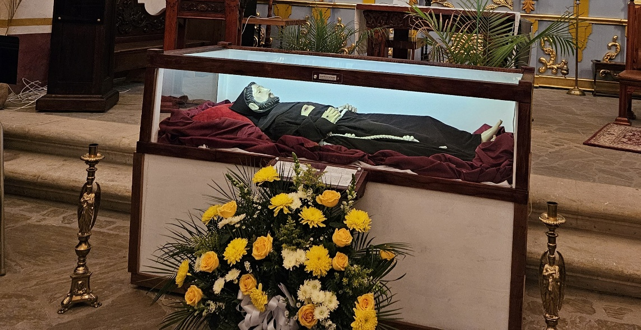
The San Antonio Franciscan Family will celebrate the Transitus of St. Francis on Friday evening the 3rd of October at Our Lady of Guadalupe Shrine, 1321 El Paso, San Antonio, TX 78207. The service traditionally begins at sundown. That is approximately 7pm. Come early to obtain a good seat and park in the rear of the Shrine. That parking entrance is on San Fernando Street across from Lanier High School.

Next Fraternity Meeting: Sunday, October 19, 2025 (3rd Sunday)
St. Francis Parish Hall, San Jose Mission, San Antonio, TX

12:00-12:30PM Professed Member Arrival & Social Time – bring your food items. Please bring canned goods (the pop-top kind) for our donation to St. Vincent de Paul at one of the San Antonio Parishes. Please also bring any socks, gloves, or hats for our outreach to the homeless.
(A-J) Side Dishes
(K-Z) Main Dishes
We will be using the office of the deceased or this October meeting. You are encouraged to bring photos of your deceased loved ones for our Fraternity Day of the Dead Altar.

12:30PM Rosary followed by Liturgy of the Hours for our deceased members and family

1:00PM Fraternity Social and Meeting

4:00PM Adjourn
Save the Dates:
- October 3, 2025, Transitus of St. Francis, Our Lady of Guadalupe Shrine; 7PM
A Reception will follow; sponsored by St. Francis Fraternity and San Jose Fraternity
- October 11, 2025, Fiesta Franciscana, St. Francis Parish Center @ San Jos –8am-4pm
- October 19, 2025 Fraternity Meeting, 3rd Sun, St. Francis Center @ San Jose Mission
- Nov 16, 2025, Fraternity Meeting, 3rd Sun, St. Francis Center @ San Jose Mission

PRAYER LIST: Continued prayers for health and spiritual blessings for all our members and their family members, and most especially:

Alice McRae, ofs, Maggie Padilla, ofs, Lois Guckian, ofs, Mary Zanyi, ofs, Petra Macias, ofs, Raquel Gomez, ofs, Ana Gaus, ofs, Maria de Jesus Rios, ofs, and Maria’s niece, Frances Rosales, ofs, Lydia Ramon, ofs, and Mary Solomon, ofs.

OCTOBER BIRTHDAY: Feliz Cumpleaños!!
Frances Rosales. October 5th
Lois Guckian, October 12th
Petra Macias, October 19th

OCTOBER PROFESSION:
Gino & Petra Macias 10/26/1995
Mary Zanyi, 10/4/1983

CALENDAR OF FRANCISCAN SAINTS for October – Month of the Holy Rosary and the Holy Angels
1. Bl. Nicolas of Forca, Priest, religious of the Third-Order Regular [living in community, under a Rule], d. 1449
2. Bl. Antoine Chevrier, Priest, religious of the Third-Order Regular [living in community, under a Rule], d. 1879
3. St. Therese of the Infant Jesus, Patron of France; St. Marie-Joseph Tossello, Virgin, Franciscan Third Order Secular, d. 1880
4. Solemnity of our Seraphic Father St. Francis, d. 1226, Plenary Indulgence for tertiaries and cordbearers
5. Commemoration of the establishment of the 3 Orders/ Blessed Felicia Meda, Order of Poor Clares, d. 1444
6. St. Mary Frances of the Five Wounds, Virgin, Franciscan Third Order Secular
7. Feast of the Holy Rosary
8. St. Bridget of Sweden, Virgin, Franciscan Third Order Secular, d. 1373
9. Bl. Marie-Angele Truszkowska, Virgin, religious of the Third-Order Regular [living in community, under a Rule], d. 1899
10. St. Francois Borgia, Priest, had been a tertiary before founding or joining another religious Institute, d. 1572; and St. Daniel and Companions, Religious of the Franciscan 1st Order, Martyrs, d. 1227
11. Feast of the Divine Maternity of Our Lady
12. St. Seraphin of Montegranaro, lay brother, Capuchin religious, d. 1604
13. Bl. Pacifique de Valence, lay brother, Capuchin religious, martyr 1936
14. St John of Dukla, Priest, religious of the Franciscan 1st Order, martyr 1936
15. Bl. Sebastien de Jesus, lay brother, religious of the Franciscan 1st Order, d. 1734
16. Bl. Anicet de Dbrzno, Priest, Capuchin religious, martyr, 1941
17. Bl. Balthassar of Chiavari, Priest, religious of the Franciscan 1st Order, d. 1490
18. Bl. James of Strepar, Bishop, religious of the Franciscan 1st Order, d. 1409
19. St. Peter of Alcantara, Priest, religious of the Franciscan 1st Order, d. 1512
20. Bl. Contardo Ferrini, Confessor, Franciscan Third Order Secular, d. 1902
21. Bl. Martyrs of Polonais, d. 1941-42
22. Bl. John Baptist Bullaker, Priest, religious of the Franciscan 1st Order, martyr 1642
23. St. Anthony Mary Claret, Bishop, had been a tertiary before founding or joining another religious Institute, d. 1870
24. Bl. Josephine Leroux, Virgin, the Franciscan 2nd-Order; a "Poor Clare" sister, martyr 1794
25. Bl. Maria Veronica Masia Ferragut, Bl. Maria Felicidad Masia Ferragut, and Bl. Jesus Masia Ferragut, Virgins, Capuchin religious, Martyrs 1936
26. Bl. Martyrs of the War of Spain, 1936-37
27. Bl. Bonaventure of Potenza, Priest, Conventual religious, d. 1711
28. Bl. Anne-Eugenie Picco, Virgin, had been a tertiary before founding or joining another religious Institute, d. 1921
29. Bl. Thomas of Florence, lay brother, religious of the Franciscan 1st Order, d. 1447
30. Bl. Angelo of Acre, Priest, Capuchin religious, d. 1739
31. Bl. Christophe de Cahors, Priest, religious of the Franciscan 1st Order, d. 1272

Apostolate for Food Banks: Please bring can goods (the Pop-Top kind only) to our monthly gatherings. We will collect these and distribute to one of our local parishes who have food distribution to the poor.
Apostolate for Homeless: Please bring items to pass to the homeless at the breakfast at Our Lady of Guadalupe Shrine. Needed are: SOCKS, Hats, Glover, Scarfs, small toiletry items.
Food for the Homeless: At Our Lady of Guadalupe Shrine, Br. Jaime’s Franciscan Outreach Ministry is at work every week usually in the mornings (Mon, Tues, Thru, & Fri) around 8:00am. We can try to help in the kitchen during the week to help Br. Jaime. They serve around 9:30-12. They start cooking around 8:30am.

Prayer Apostolate: The Fraternity will be praying for those special intentions that often do not become verbalized. We placed a box in San Jose Mission Church where anyone may place a written note with the person’s name or the intention subject. The initial outpouring of prayer requests has been extraordinary. Each member present at our September gathering took ‘handfuls’ of prayer intentions to remember during the next month.
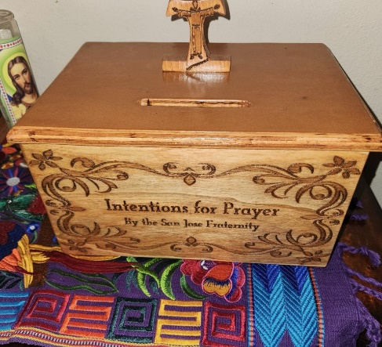

TAU Newsletter of the National Fraternity: The NAFRA Newsletter is published 4 times per year. The Summer 2025 issue was distributed to members attending the August San Jose Fraternity Gathering. It may be found on the following Internet connection: TAU-USA Magazine – Secular Franciscan Order – USA. Look for this Newsletter’s Fall issue.
Catechism of the Catholic Church

218. What is the liturgy? The liturgy is the celebration of the mystery of Christ and in particular his paschal mystery. Through the exercise of the priestly office of Jesus Christ the liturgy manifests in signs and brings about the sanctification of humankind. The public worship which is due to God is offered by the Mystical Body of Christ, that is, by its head and by its members. Further reading: CCC 1066-1070

219. What place does the liturgy occupy in the life of the Church? The liturgy as the sacred action par excellence is the summit toward which the activity of the Church is directed and it is likewise the font from which all her power flows. Through the liturgy Christ continues the work of our redemption in, with and through his Church. Further reading: CCC 1071-1075
220. In what does the sacramental economy consist? The sacramental economy consists in the communication of the fruits of Christ's redemption through the celebration of the sacraments of the Church, most especially that of the Eucharist, "until he comes" (1 Corinthians 11:26). Further reading: CCC 1076

221. In what way is the Father the source and the goal of the liturgy? Through the liturgy the Father fills us with his blessing in the Word made flesh who died and rose for us and pours into our hearts the Holy Spirit. At the same time, the Church blesses the Father by her worship, praise, and thanksgiving and begs him for the gift of his Son and the Holy Spirit. Further reading: CCC 1077-1083, 1110
222. What is the work of Christ in the liturgy? In the liturgy of the Church, it is his own paschal mystery that Christ signifies and makes present. By giving the Holy Spirit to his apostles he entrusted to them and their successors the power to make present the work of salvation through the Eucharistic sacrifice and the sacraments, in which he himself acts to communicate his grace to the faithful of all times and places throughout the world. Further reading: CCC 1084-1090

Pax et Bonum! Peace and All Good!! Paz y Bien!
Suzanne Salinas-Valdillez, ofs, Minister; 7710 Tourney Oak Dr. San Antonio, TX 78223

