 “Ordo Franciscanus Saecularis”
San Jose Fraternity San Antonio, Texas Secular Franciscan Order

November 2025
Fraternity Council
Minister: Suzanne Salinas-Valdillez, ofs
Vice Minister: Mary Basile, ofs
Secretary: Judith Hooge, ofs
Treasurer: George Irving, ofs
Formation Director: María de Jesús Ríos, ofs
Spiritual Assistant Friar Dennis Schafer, ofm

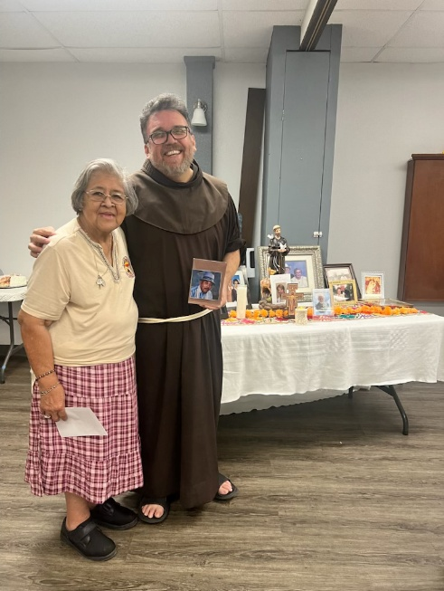

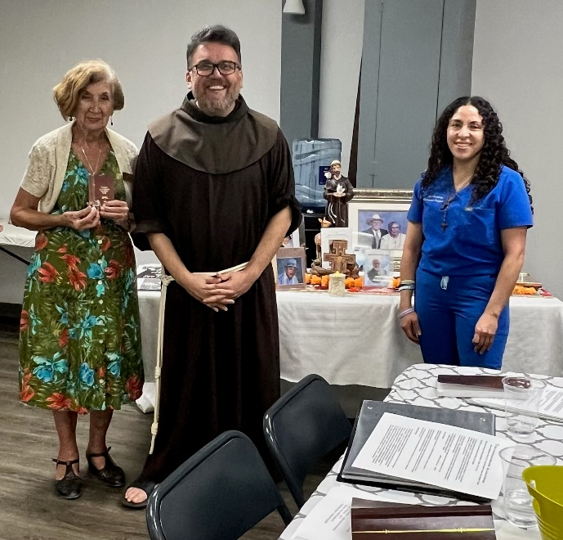
Lupita Lopez and Maui Martinez were welcomed
Bro. Adolfo Martinez, ofm, celebrates 50 years of into the Secular Franciscan order during our
Profession for Petra Macias, ofs. San Jose Fraternity October 2025 Fraternity Gathering. Bro Adolfo
also remembered our deceased members and family Martinez, ofm, began their Initial Formation in
with photos displayed on the table in the background. Spanish.

Next Fraternity Meeting: Sunday, November 16, 2025 (3rd Sunday)
St. Francis Parish Hall, San Jose Mission, San Antonio, TX

12:00-12:30PM Professed Member Arrival & Social Time – bring your food items. Please bring canned goods (the pop-top kind) for our donation to St. Vincent de Paul at one of the San Antonio Parishes. Please also bring any socks, gloves, or hats for our outreach to the homeless.
(A-J) Main Dishes
(K-Z) Side Dishes

12:30PM Rosary followed by Liturgy of the Hours for the thirty-third Sunday in Ordinary time.

1:00PM Fraternity Social and Meeting

4:00PM Adjourn
Save the Dates:
- November 15, 2025: St. Francis Fraternity has invited our San Jose Fraternity to join them for their Thanksgiving Meal at the OLOG Shrine Parish Hall at 1:00PM
- Nov 16, 2025, Fraternity Meeting, 3rd Sun, St. Francis Center @ San Jose Mission. This meeting will explore the topic St. Francis the Soldier. Veterans are invited to attend. Members are encouraged to reach out to a Veteran and invite them to the meeting.
- Dec 21, 2025, Fraternity Meeting, 3rd Sun, St Francis Center @ San Jose Mission
- Jan 18, 2026, Fraternity Meeting, 3rd Sun, St. Francis Center @ San Jose Mission

PRAYER LIST: Continued prayers for health and spiritual blessings for all our members and their family members, and most especially:

Alice McRae, ofs, Maggie Padilla, ofs, Lois Guckian, ofs, Mary Zanyi, ofs, Petra Macias, ofs, Raquel Gomez, ofs, Ana Gaus, ofs, Maria de Jesus Rios, ofs, and Maria’s niece, Frances Rosales, ofs, Lydia Ramon, ofs, Sharonann Brunet, ofs, and Mary Solomon, ofs.

NOVEMBER BIRTHDAY: Feliz Cumpleaños!!
Florencio Sepulveda, ofs

NOVEMBER PROFESSION: None

CALENDAR OF FRANCISCAN SAINTS for November – Month of the Holy Souls in Purgatory
1. Feast of All Saints – Holy day of Obligation
2. Commemoration of all of the Faithfully Departed – Plenary Indulgence for the holy souls when one visits a church or chapel and recites a Pater and a Credo
3. Bl. Helen Enselmini, Virgin, the Franciscan 2nd-Order; a "Poor Clare" sister, d. 1231
4. St. Charles Borromeo, Bishop, Franciscan Third Order Secular, d. 1584
5. Feast of the Saints Relics
6. Bl. Margaret of Lorraine, Virgin, the Franciscan 2nd-Order; a "Poor Clare" sister, d. 1521
7. Bl. Raynier of Arezzo, lay brother, religious of the Franciscan 1st Order, d. 1304
8. Bl. John Duns Scotus, Priest, religious of the Franciscan 1st Order, d. 1308
9. Bl. Gabriel Ferritti, Priest, religious of the Franciscan 1st Order, d. 1456
10. Bl. Louis Guanella, Priest, Franciscan Third Order Secular, d. 1915
11. Bl. Mary Crucifixa, Virgin, the Franciscan 3nd-Order; a "Poor Clare" sister, d. 1826
12. Bl. John of Peace, Confessor, religious of the Third-Order Regular [living in community, under a Rule], d. 1340
13. St. Didacus of Alcala, lay brother, religious of the Franciscan 1st Order, d. 1463
14. St. Nicholas Tavelich and Companions, Martyrs, religious of the Franciscan 1st Order, d. 1391
15. Bl. Sebastien de Jesus, lay brother, religious of the Franciscan 1st Order, d. 1734
16. St. Agnes of Assisi, Virgin, the Franciscan 2nd-Order; a "Poor Clare" sister, d. 1253
17. Bl. Jane of Signa, Virgin, Franciscan Third Order Secular, d. 1307
18. Bl. Salome of Cracow, Virgin, the Franciscan 2nd-Order; a "Poor Clare" sister, d. 1268
19. St. Elizabeth of Hungary, Virgin Patroness of Franciscan Third Order Secular, Plenary Indulgence (renewal of Tertiary engagement), d. 1231
20. Bl. Migagros Ortells, Virgin, Capuchin religious, Martyr 1936
21. Feast of the Presentation of the Holy Virgin Mary
22. Bl. Salvator Lilli, Priest, religious of the Franciscan 1st Order, martyr 1895
23. Bl. Marie de Jesus Bon Pasteur, Virgin, religious of the Third-Order Regular [living in community, under a Rule], d. 1902
24. Bl. Timothy Trajonowski, lay brother, Conventual religious, martyr 1942
25. Bl. Humilis of Bisignano, lay brother, religious of the Franciscan 1st Order, d. 1637
26. St. Leonard of Port Maurice, Priest, religious of the Franciscan 1st Order, d. 1751
27. St. Francis Anthony Fasani, Priest, Conventual religious, d. 1742
28. St. James of the March, Priest, religious of the Franciscan 1st Order, d. 1476
29. Saints of the Seraphic Order
30. Bl. Anthony Bonfadini, Priest, religious of the Franciscan 1st Order, d. 1482

Apostolate for Food Banks: Please bring can goods (the Pop-Top kind only) to our monthly gatherings. We will collect these and distribute to one of our local parishes who have food distribution to the poor.
Apostolate for Homeless: Please bring items to pass to the homeless at the breakfast at Our Lady of Guadalupe Shrine. Needed are: SOCKS, Hats, Glover, Scarfs, small toiletry items.
Food for the Homeless: At Our Lady of Guadalupe Shrine, Br. Jaime’s Franciscan Outreach Ministry is at work every week usually in the mornings (Mon, Tues, Thru, & Fri) around 8:00am. We can try to help in the kitchen during the week to help Br. Jaime. They serve around 9:30-12. They start cooking around 8:30am.

Prayer Apostolate: The Fraternity will be praying for those special intentions that often do not become verbalized. We placed a box in San Jose Mission Church where anyone may place a written note with the person’s name or the intention subject. The initial outpouring of prayer requests has been extraordinary. Each member present at our October gathering took ‘handfuls’ of prayer intentions to remember during the next month.
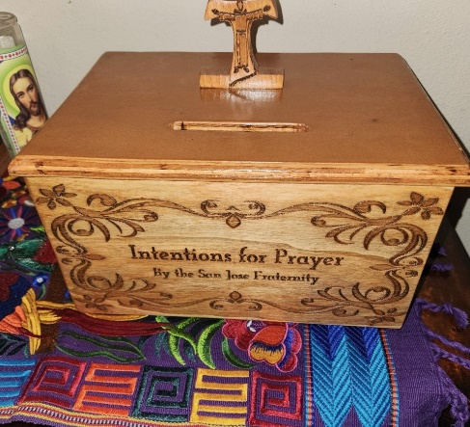

TAU Newsletter of the National Fraternity: The NAFRA Newsletter is published 4 times per year. The Summer 2025 issue was distributed to members attending the August San Jose Fraternity Gathering. It may be found on the following Internet connection: TAU-USA Magazine – Secular Franciscan Order – USA. Look for this Newsletter’s Fall issue.
Catechism of the Catholic Church

223. How does the Holy Spirit work in the liturgy of the Church? The very closest cooperation is at work in the liturgy between the Holy Spirit and the Church. The Holy Spirit prepares the Church to encounter her Lord. He recalls and manifests Christ to the faith of the assembly. He makes the mystery of Christ really present. He unites the Church to the life and mission of Christ and makes the gift of communion bear fruit in the Church.
Further reading: CCC 1091-1109, 1112

224. What are the sacraments and which are they? The sacraments, instituted by Christ and entrusted to the Church, are efficacious signs of grace perceptible to the senses. Through them divine life is bestowed upon us. There are seven sacraments: Baptism, Confirmation, Holy Eucharist, Penance, Anointing of the Sick, Holy Orders and Matrimony.
Further reading: CCC 1113-1131
225. What is the relationship of the sacraments to Christ? The mysteries of Christ's life are the foundations of what he would henceforth dispense in the sacraments, through the ministers of his Church. “What was visible in our Savior has passed over into his mysteries."
(Saint Leo the Great)
Further reading: CCC 461-463, 483

226. What is the link between the sacraments and the Church? Christ has entrusted the sacraments to his Church. They are the sacraments "of the Church" in a twofold sense: they are "from her" insofar as they are actions of the Church which is the sacrament of Christ's action; and they are "for her" in as much as they build up the Church.
Further reading: CCC 1117 - 1119
227. What is the sacramental character? It is spiritual "seal" bestowed by the sacraments of Baptism, Confirmation, and Holy Orders. It is a promise and guarantee of divine protection. By virtue of his seal the Christian is configured to Christ, participates in a variety of ways in his priesthood and takes his part in the Church according to different states and functions. He is, therefore, set apart for divine worship and the service of the Church. Because this character is indelible the sacraments that impress it on the soul are received only once in life. Further reading: CCC 1121

Pax et Bonum! Peace and All Good!! Paz y Bien!
Suzanne Salinas-Valdillez, ofs, Minister; 7710 Tourney Oak Dr. San Antonio, TX 78223

