 “Ordo Franciscanus Saecularis”
San Jose Fraternity San Antonio, Texas Secular Franciscan Order

December 2025
Fraternity Council
Minister: Suzanne Salinas-Valdillez, ofs
Vice Minister: Mary Basile, ofs
Secretary: Judith Hooge, ofs
Treasurer: George Irving, ofs
Formation Director: María de Jesús Ríos, ofs
Spiritual Assistant Friar Dennis Schafer, ofm

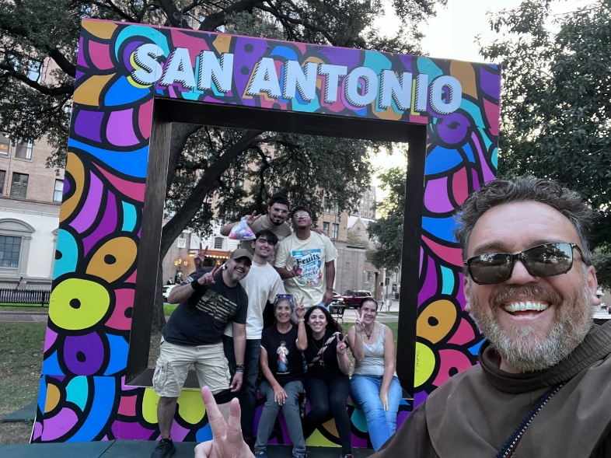
Bro. Aldofo, ofm and members of our San Jose Fraternity provided assistance to many homeless during the Thanksgiving holiday period.

Next Fraternity Meeting: Sunday, December 21, 2025 (3rd Sunday)
St. Francis Parish Hall, San Jose Mission, San Antonio, TX

12:00-12:30PM Professed Member Arrival & Social Time – bring your food items. Please bring canned goods (the pop-top kind) for our donation to St. Vincent de Paul at one of the San Antonio Parishes. Please also bring any socks, gloves, or hats for our outreach to the homeless.
The Fraternity will provide a spiral cut ham.
Everyone please bring a side dish or a dessert.
12:30PM Rosary followed by Liturgy for Christmas.

1:00PM Fraternity Social and Meeting

4:00PM Adjourn
Save the Dates:
- Dec 21, 2025, Fraternity Meeting, 3rd Sun, St Francis Center @ San Jose Mission
- Jan 18, 2026, Fraternity Meeting, 3rd Sun, St. Francis Center @ San Jose Mission
- Feb 15, 2026 Fraternity Meeting, 3rd Sun, St. Francis Center @ San Jose Mission
- March 15, 2026 Fraternity Meeting, 3rd Sun, St. Francis Center @ San Jose Mission
- April 19, 2026 Fraternity Meeting, 3rd Sun, St. Francis Center @ San Jose Mission

At our November Fraternity Gathering we honored all veterans. Fr. Dennis presented an excellent talk on “Francis the Soldier”. We had 14 visitors, many of whom were Veterans.

PRAYER LIST: Continued prayers for health and spiritual blessings for all our members and their family members, and most especially:

Alice McRae, ofs, Maggie Padilla, ofs, Lois Guckian, ofs, Mary Zanyi, ofs, Petra Macias, ofs, Raquel Gomez, ofs, Ana Gaus, ofs, Maria de Jesus Rios, ofs, and Maria’s niece, Frances Rosales, ofs, Lydia Ramon, ofs, Sharonann Brunet, ofs, and Mary Solomon, ofs.

DECEMBER BIRTHDAY: ¡¡Feliz Cumpleaños!!

Alice McCrae, ofs
Henry Ramon, ofs

DECEMBER PROFESSION:
George Irving, ofs, December 17, 1978
Mary Basile, ofs, December 20, 2015
Lydia Ramon, ofs, December 20, 2015
Yolanda Montoya, ofs, December 17, 2017
Margarita Padilla, ofs, December 16, 2018

CALENDAR OF FRANCISCAN SAINTS for December – Month of the Incarnation
1. Bl Marie-Angele Astorch, Virgin, Capuchin religious, d. 1665
2. Bl. Raphael Chylinski, Priest, religious of the Franciscan 1st Order, d. 1741
3. St. Francis Xavier, Priest, had been a tertiary before founding or joining another religious Institute, Martyr, 1623
4. Bl. Francois Galves, Priest, religious of the Franciscan 1st Order, Martyr 1623
5. Bl. Peter of Siena, Confessor, Franciscan Third Order Secular, d. 1289
6. Bl. Elisabeth la Bonne, Virgin, Franciscan Third Order Secular, d. 1420
7. Bl. Louis Beltrame Quattrocchi, Confessor, religious of the Franciscan 1st Order, d. 1951
8. Feast of the Immaculate Conception, Patroness of the Seraphic Order, Holy Day of Obligation, Plenary Indulgence for tertiaries and cordbearers
9. Bl. Delphine de Glandeves, Virgin, Franciscan Third Order Secular, d. 1360
10. Bl. Conrad of Offida, Priest, religious of the Franciscan 1st Order, d. 1306
11. Bl. Hugolinus Magalotti, Confessor, Franciscan Third Order Secular, d. 1373
12. Discovery of the tomb of St. Francis 1820
13. Bl. Pius Bartosik, Priest, Conventual religious, Martyr 1941
14. Bl. Barthole Buonpedini, Priest, Franciscan Third Order Secular, d. 1300
15. Mary Queen of the Seraphic Order
16. Bl. Honorat de Biala, Priest, Capuchin religious, d. 1916
17. Bl. Francois Bell, Priest, religious of the Franciscan 1st Order, Martyr 1643
18. Bl. Mary Francis Schervier, Virgin, religious of the Third-Order Regular [living in community, under a Rule], d. 1876
19. Bl. Jean Discalceat, Priest, religious of the Franciscan 1st Order, d. 1349
20. Bl. Antoine Galvao, Priest, religious of the Franciscan 1st Order, d. 1822
21. St. Raphael Kalinowski, Priest, had been a tertiary before founding or joining another religious Institute, d. 1907
22. St. Francis Xavier Cabrini, Virgin, had been a tertiary before founding or joining another religious Institute, d. 1917
23. Bl. Nicolas Factor, Priest, religious of the Franciscan 1st Order, d. 1583
24. Bl. Bentivolio of Bonio, Priest, religious of the Franciscan 1st Order, d. 1231
25. Nativity of Our Lord Jesus Christ, Holy Day of Obligation
26. St. Albert Chmielowski, Confessor, religious of the Third-Order Regular [living in community, under a Rule], d. 1916
27. Bl. Matthia Nazzarei, Virgin, the Franciscan 2nd-Order; a "Poor Clare" sister, d. 1320
28. Feast of the Holy Innocents
29. Bl Gerard Cagnoli, lay brother, religious of the Franciscan 1st Order, d. 1342
30. Bl. Margaret Colonna, Virgin, the Franciscan 2nd-Order; a "Poor Clare" sister, d. 1280
31. St. Gaspard Buffalo, Priest, Franciscan Third Order Secular, d. 1836; Plenary Indulgence (Chant the Te Deum in public)

Prayer Apostolate: The Fraternity will be praying for those special intentions that often do not become verbalized. We placed a box in San Jose Mission Church where anyone may place a written note with the person’s name or the intention subject. The initial outpouring of prayer requests has been extraordinary. Each member present at our monthly gathering took ‘handfuls’ of prayer intentions to remember during the next month.
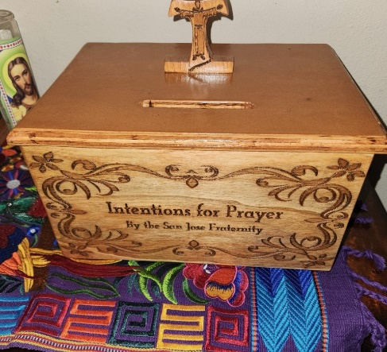

Apostolate for Food Banks: Please bring can goods (the Pop-Top kind only) to our monthly gatherings. We will collect these and distribute to one of our local parishes who have food distribution to the poor.
Apostolate for Homeless: Please bring items to pass to the homeless at the breakfast at Our Lady of Guadalupe Shrine. Needed are: SOCKS, Hats, Glover, Scarfs, small toiletry items.
Food for the Homeless: At Our Lady of Guadalupe Shrine, Br. Jaime’s Franciscan Outreach Ministry is at work every week usually in the mornings (Mon, Tues, Thru, & Fri) around 8:00am. We can try to help in the kitchen during the week to help Br. Jaime. They serve around 9:30-12. They start cooking around 8:30am.
TAU Newsletter of the National Fraternity: The NAFRA Newsletter is published 4 times per year. The Fall 2025 issue has been published. It may be found on the following Internet connection: TAU-USA Magazine – Secular Franciscan Order – USA. Look for this Tau Winter issue.
Catechism of the Catholic Church

228. What is the relationship between the sacraments and faith? The sacraments not only presuppose faith but with words and ritual elements they nourish, strengthen, and express it. By celebrating the sacraments, the Church professes the faith that comes from the apostles. This explains the origin of the ancient saying "Lex ordandi, lex credendi," that is, the Church believes as she prays. Further reading: CCC 1122-1126, 1133
229. Why are the sacraments efficacious? The sacraments are efficacious ex opere operato ("by the very fact that the sacramental action is performed") because it is Christ who acts in the sacraments and communicates the grace they signify. The efficacy of the sacraments does not depend upon the personal holiness of the minister. However, the fruits of the sacraments do depend on the dispositions of the one who receives them.
Further reading: CCC 1127-1128, 1131

230. For what reason are the sacraments necessary for salvation? For believers in Christ the sacraments, even if they are not all given to each of the faithful, are necessary for salvation because they confer sacramental grace, forgiveness of sins, adoption as children of God, conformation to Christ the Lord and membership in the Church. The Holy Spirit heals and transforms those who receive the sacraments. Further reading: CCC 1129
231. What is sacramental grace? Sacramental grace is the grace of the Holy Spirit which is given by Christ and is proper to each sacrament. This grace helps the faithful in their journey toward holiness and so assists the Church as well to grow in charity and in her witness to the world. Further reading: CCC 1129, 1131, 1134, 2003
232. What is the relationship between the sacraments and everlasting life? In the sacraments the Church already receives a foretaste of eternal life, while "awaiting in blessed hope, the appearing in glory of our great God and savior Christ Jesus" (Titus 2:13).
Further reading: CCC 1130

Pax et Bonum! Peace and All Good!! Paz y Bien!
Suzanne Salinas-Valdillez, ofs, Minister; 7710 Tourney Oak Dr. San Antonio, TX 78223

