 “Ordo Franciscanus Saecularis”
San Jose Fraternity San Antonio, Texas Secular Franciscan Order
August 2026
Fraternity Council
Minister: Suzanne Salinas-Valdillez, ofs
Vice Minister: Mary Basile, ofs
Secretary: Judith Hooge, ofs
Treasurer: George Irving, ofs
Formation Director: María de Jesús Ríos, ofs
Spiritual Assistant Friar Dennis Schafer, ofm

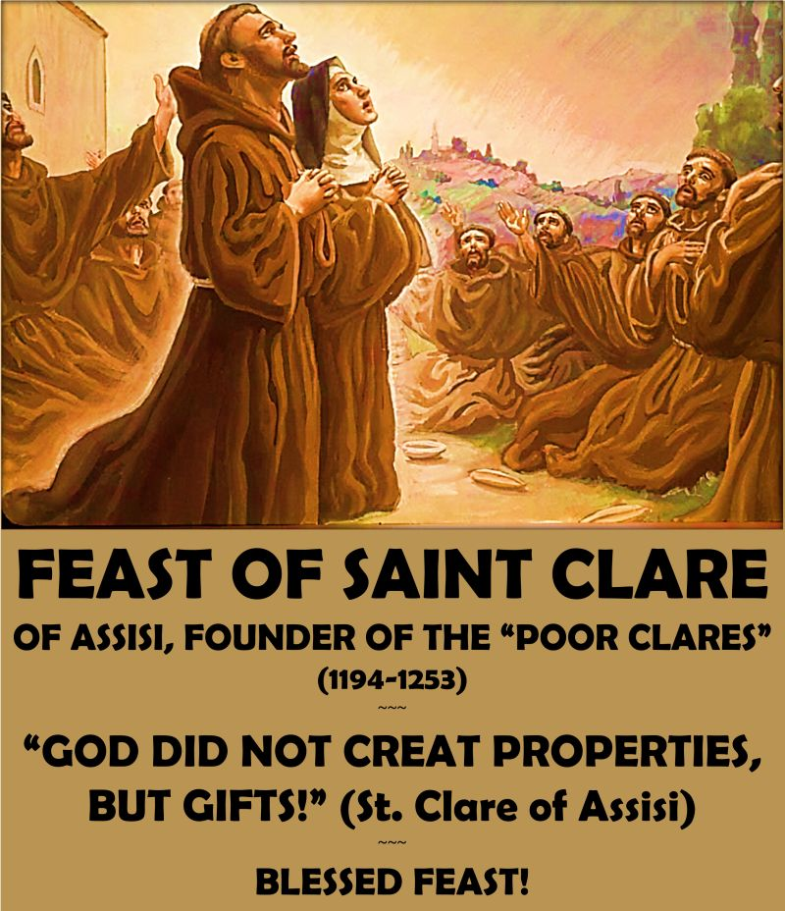

Next Fraternity Meeting: Sunday, August 16, 2026 (3rd Sunday)
St. Francis Parish Hall, San Jose Mission, San Antonio, TX

12:00-12:30PM: Professed Member Arrival & Social Time – bring your food items. Please bring canned goods (the pop-top kind) for our donation to St. Vincent de Paul at one of the San Antonio Parishes. Please bring any socks, gloves, or hats for our homeless outreach.
(A-J) Main Dishes
(K-Z) Side Dishes

12:30PM Rosary

1:00PM Fraternity Social followed by Ongoing Formation and Meeting

4:00PM Fraternity Meeting and Adjourn

Save the Dates:
- August 16, 2026, Fraternity Meeting, 3rd Sun, St. Francis Center @ San Jose Mission
- September 20, 2026, Fraternity Meeting, 3rd Sun. Mission San Juan
- Fiesta Franciscana, Saturday 3 October 2026, St. Francis Center at San Jose Mission
- October 18, 2026, Fraternity Meeting, 3rd Sun, St. Francis Center @ San Jose Mission

PRAYER LIST: Continued prayers for health and spiritual blessings for all our members and their family members, and most especially:

Raquel Gomez, ofs, Frances Rosales, ofs, Alice McRae, ofs, Lois Guckian, ofs, Mary Zanyi, ofs, Petra Macias, ofs, Ana Gaus, ofs, Maria de Jesus Rios, ofs, Lydia Ramon, ofs, Sharonann Brunet, ofs, and Mary Solomon, ofs. Let us also remember all the homeless folks in San Antonio.
Pray for the intention of the Holy Father for July: For Evangelization in the city.

The Portiuncula Indulgence – August 2 – This is a Grace not to be missed—not only for yourself but for the many suffering souls in Purgatory. Please make plans on Sunday, August 2, to attend Holy Mass and receive Communion. The conditions to obtain the Plenary Indulgence of the Forgiveness of Assisi is (for oneself or for a departed soul) is as follows:
Sacramental Confession to be in God’s grace (during eight days before or after the 2nd of August)
Participation in the Holy Mass and Eucharist
Recitation of The Apostles Creed, Our Father, Hail Mary, and Glory Be for the Pope’s Intentions

Our San Jose Fraternity has begun planning for the celebration of our 100th anniversary of Fraternity Establishment that occurred in March 1932. We will be planning events throughout calendar year 2032.

Please Pray for the canonization of Fr. Margil de Jesus. Margil’s canonization process began shortly after his death, formally opening on July 19, 1769. The next step toward beatification requires verifying a miracle attributed to Margil’s intercession, with a second miracle needed for full canonization.
Recently, the Archdiocese of San Antonio honored Padre Margil by creating the Padre Margil Pilgrimage Center, home to El Camino de San Antonio Missions. Located behind Mission Concepción at 263 Felisa St., the center promotes pilgrimage to the San Antonio Missions and Cathedral, preserving Margil’s legacy through interactive exhibits and a short film. Venerable Margil’s influence endures in San Antonio through Mission San José. The faithful are encouraged to seek his intercession privately, praying for miracles to advance his canonization.

AUGUST BIRTHDAY: Feliz Cumpleaños!! Judith Hooge, ofs August 3rd

AUGUST PROFESSION: Suzanne Salinas-Valdillez, ofs, August 18, 2024

Calendar of Franciscan Saints for August - Month of the Immaculate Heart of Mary
St. Alphonse de Liguori, Bishop, had been a tertiary before founding or joining another religious Institute, d. 1787
2. Our Lady of the Angels of the Portiuncula, Plenary Indulgence possible by visiting a church or chapel of the Franciscan 1st Order
3. St. Pierre-Julien Eymard, Priest, had been a tertiary before founding or joining another religious Institute, d. 1868
4. St. Dominic, Priest, Cordbearer, d. 1221
5. B. Marie-Francoise de Jesus, Virgin, religious of the Third-Order Regular [living in community, under a Rule], d. 1904
6. Transfiguration of Our Lord Jesus Christ
7. Bl. Agathange et Cassien, Priest, Capuchin, martyr 1638
8. St. Jean-Marie Vianney, Priest, Franciscan Third Order Secular, d. 1859
9. Bl. Marie-Marguerite of the Sacred Heart, Virgin, religious of the Third-Order Regular [living in community, under a Rule], d. 1924
10. St. Beatrice de Silva, Virgin, of the Franciscan 2nd-Order; a "Poor Clare" sister, d. 1492
11. Bl. Innocent XI, Pope, Franciscan Third Order Secular, d. 1689
11. St. Clare of Assisi, Virgin, Foundress of the Poor Clares, Plenary Indulgence for Tertiaries (Renewal of Engagements)
13. Bl. Novellon de Faenza, Confessor, Franciscan Third Order Secular, d. 1280
14. St. Maximilien-Marie Kolbe, Priest, Conventual religious, martyr 1941
15. Feast of the Assumption of Our Lady
16. Bl. Francis Chici of Pesaro, Confessor, Franciscan Third Order Secular, d. 1350
17. St. Roch of Montpellier, Confessor, Franciscan Third Order Secular, d. 1327
18. Blessed Martyrs of Pontons de Rochefort, d. 1794
19. St. Jean Eudes, Priest, had been a tertiary before founding or joining another religious Institute, d. 1680
20. St. Louis of Anjou, Bishop of Toulouse, religious of the Franciscan 1st Order, d. 1297
21. St. Jeanne-Francoise de Chantal, Virgin, Franciscan Third Order Secular, d. 1610
22. Feast of the Immaculate Heart of Mary
23. Bl. Bernard of Offida, lay brother, Capuchin religious, d. 1694
24. St. Emilie de Vialar, Virgin, religious of the Third-Order Regular [living in community, under a Rule], d. 1856
25. St. Louis IX, King of France, Patron of Franciscan Third Order Seculars, Plenary Indulgence for tertiaries and cordbearers
26. Bl. Pierre de Benisa, Priest, Capuchin religious, martyr 1936
27. St. Joseph Calasanz, Priest, Cordbearer, d. 1648
28. St. Junipero Serra, Priest, religious of the Franciscan 1st Order, d. 1784
29. Bl. Jean de Perouse, Priest, religious of the Franciscan 1st Order, d. 1231
30. Bl. Juvenal Ancina, Bishop, Franciscan Third Order Secular, d. 1604
31. Bl. Aurele de Vinalesa, Priest, Capuchin religious, martyr 1936

Visits to Fraternity Members: Many of our Fraternity members are ill or lack the ability to travel to our monthly gatherings. Margie Gonzalez, ofs, has suggested that we make visits to these individuals. If you are interested, please contact Margie: 210-324-1248.

Prayer Apostolate: The Fraternity will be praying for those special intentions that often do not become verbalized. We placed a box in San Jose Mission Church where anyone may place a written note with the person’s name or the intention subject. The outpouring of prayer requests has been extraordinary. Each member present at our monthly gathering took ‘handfuls’ of prayer intentions to remember during the next month.
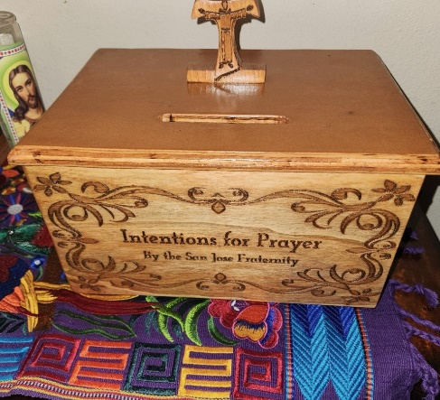

Apostolate for Food Banks: Please bring can goods (the Pop-Top kind only) to our monthly gatherings. We will collect these and distribute to one of our local parishes who have food distribution to the poor.
Apostolate for Homeless: Please bring items to pass to the homeless at the breakfast at Our Lady of Guadalupe Shrine. Needed are: SOCKS, Hats, Glover, Scarfs, small toiletry items.
Food for the Homeless: At Our Lady of Guadalupe Shrine, Br. Jaime’s Franciscan Outreach Ministry is at work every week usually in the mornings (Mon, Tues, Thru, & Fri) around 8:00am. We can try to help in the kitchen during the week to help Br. Jaime. They serve around 9:30-12. They start cooking around 8:30am.
Catechism of the Catholic Church
273. How did he institute the Eucharist? After he had gathered with his apostles in the Cenacle, Jesus took bread in his hands. He broke it and gave it to them saying, "Take this and eat it, all of you; this is my Body which will be given up for you". Then, he took the cup of wine in his hands and said, "Take this and drink of this, all of you. This is the cup of my Blood, the Blood of the new and everlasting covenant. It will be shed for you and for all so that sins may be forgiven. Do this in memory of me". Further reading: CCC 1337-1340, 1365, 1406

274. What does the Eucharist represent in the life of the Church? It is the source and summit of all Christian life. In the Eucharist, the sanctifying action of God in our regard and our worship of him reach their high point. It contains the whole spiritual good of the Church, Christ himself, our Pasch. Communion with divine life and the unity of the People of God are both expressed and effected by the Eucharist. Through the eucharistic celebration we are united already with the liturgy of heaven and we have a foretaste of eternal life. Further reading: CCC 1324-1327, 1407
275. What are the names for this sacrament? The unfathomable richness of this sacrament is expressed in different names which evoke its various aspects. The most common names are: The Eucharist, Holy Mass, the Lord's Supper, the Breaking of the Bread, the Eucharistic Celebration, the Memorial of the passion, death and Resurrection of the Lord, the Holy Sacrifice, the Holy and Divine Liturgy, the Sacred Mysteries, the Most Holy Sacrament of the Altar, and Holy Communion. Further reading: CCC 1328-1332

Pax et Bonum! Peace and All Good!! Paz y Bien!
Suzanne Salinas-Valdillez, ofs, Minister; 7710 Tourney Oak Dr. San Antonio, TX 78223

