 “Ordo Franciscanus Saecularis”
San Jose Fraternity San Antonio, Texas Secular Franciscan Order
September 2026
Fraternity Council
Minister: Suzanne Salinas-Valdillez, ofs
Vice Minister: Mary Basile, ofs
Secretary: Judith Hooge, ofs
Treasurer: George Irving, ofs
Formation Director: María de Jesús Ríos, ofs
Spiritual Assistant Friar Dennis Schafer, ofm

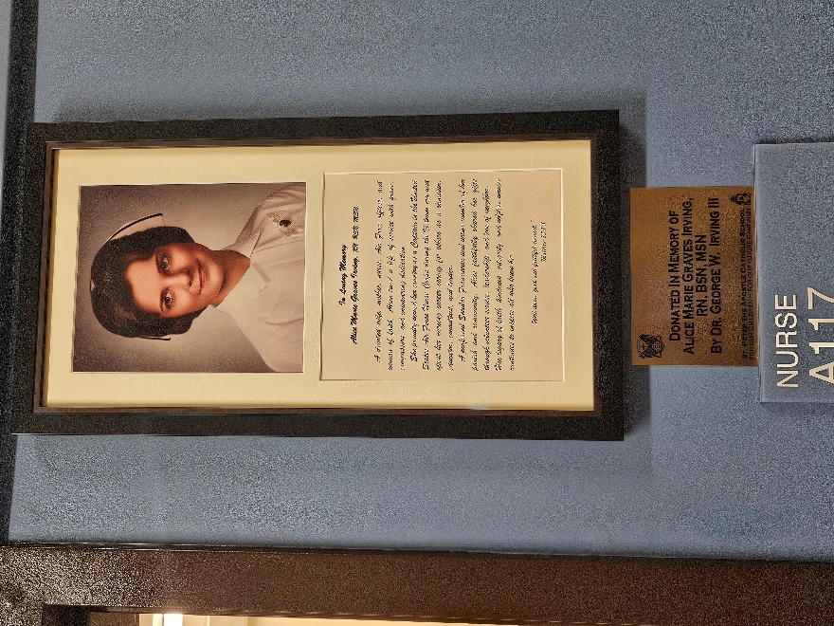

St. Peter the Apostle Parish in Boerne, TX dedicated the new grade school building on August 14th. This is the first Catholic school in 30 years in the San Antonio Archdiocese. The Nurses Station in that school is dedicated to Alice M. Irving, RN, BSN, MSN, OFS. Alice was professed in 1978 at Assumption Fraternity in Bethesda, MD. She transferred to San Jose Fraternity in San Antonio, TX in 1992. She was the fraternity minister from 2000 to 2006 and served on the Fraternity and Regional Formation Team for over 20 years. Alice passed to the arms of Our Lord on the 19th of May 2019.
Next Fraternity Gathering: Sunday, September 20, 2026 (3rd Sun)
St. Francis Parish Hall, San Jose Mission, San Antonio, TX

12:00-12:30PM: Professed Member Arrival & Social Time – bring your food items. Please bring canned goods (the pop-top kind) for our donation to St. Vincent de Paul at one of the San Antonio Parishes. Please bring any socks, gloves, or hats for our homeless outreach.
(A-J) Main Dishes
(K-Z) Side Dishes

12:30PM Liturgy of the Hours for the 25th Sunday in Ordinary Time

1:00PM Fraternity Social followed by Ongoing Formation and Meeting

4:00PM Fraternity Meeting and Adjourn

We were fortunate to have two visitors at our August Fraternity Gathering.
Our Candidate, Oscar Vela, was transferred to the St. Francis Fraternity in Aug 2026.

Save the Dates:
- September 17, 2026: Fiest of the Stigmata
- September 20, 2026, Fraternity Meeting, 3rd Sun. Mission San Juan
- Fiesta Franciscana, Saturday 3 October 2026, St. Francis Center at San Jose Mission
- October 18, 2026, Fraternity Meeting, 3rd Sun, St. Francis Center @ San Jose Mission
- November 22, 2026, Fraternity Meeting, 3rd Sun. St. Francis Center @ San Jose

PRAYER LIST: Continued prayers for health and spiritual blessings for all our members and their family members, and most especially:

Raquel Gomez, ofs, Frances Rosales, ofs, Alice McRae, ofs, Lois Guckian, ofs, Petra Macias, ofs, Ana Gaus, ofs, Maria de Jesus Rios, ofs, Lydia Ramon, ofs, Sharonann Brunet, ofs, and Mary Solomon, ofs. Let us also remember all the homeless folks in San Antonio.
Pray for the intention of the Holy Father for September: For the care of water.
Pray for the repose of the soul of our sister Mary Zanyi, ofs. The funeral mass was
August 17th in Sequin, TX. Five of our San Jose members attended.

Our San Jose Fraternity has begun planning for the celebration of our 100th anniversary of Fraternity Establishment that occurred in March 1932. We will be planning events throughout calendar year 2032.

Please Pray for the canonization of Fr. Margil de Jesus. Margil’s canonization process began shortly after his death, formally opening on July 19, 1769. The next step toward beatification requires verifying a miracle attributed to Margil’s intercession, with a second miracle needed for full canonization.
Recently, the Archdiocese of San Antonio honored Padre Margil by creating the Padre Margil Pilgrimage Center, home to El Camino de San Antonio Missions. Located behind Mission Concepción at 263 Felisa St., the center promotes pilgrimage to the San Antonio Missions and Cathedral, preserving Margil’s legacy through interactive exhibits and a short film. Venerable Margil’s influence endures in San Antonio through Mission San José. The faithful are encouraged to seek his intercession privately, praying for miracles to advance his canonization.

SEPTEMBER BIRTHDAY: Feliz Cumpleaños!! None

SEPTEMBER PROFESSION:
Maria de Jesus Rios, Sept 16, 2007
Frances Rosales ofs, Sept 16, 2007

Calendar of Franciscan Saints for September - Month of the Holy Cross
1. Bl Joachim de Albocacer, Priest, Capuchin religious, martyr 1936
2. Bl. Martyrs de Carmes, d. 1792
3. St. Pius X, Pope, Franciscan Third Order Secular, d. 1914
4. St. Rose of Viterbo, Virgin, Franciscan Third Order Secular, d. 1252 Plenary Indulgence for cordbearers
5. Bl. Gentil de Matelica, Priest, religious of the Franciscan 1st Order, martyr 1340
6. Bl. Liberatus of Lauro, Priest, religious of the Franciscan 1st Order, d. 1258
7. Bl. Eugenie Picco, Virgin, religious of the Third-Order Regular [living in community, under a Rule], d. 1921
8. Nativity of the Blessed Virgin Mary
9. Bl. Seraphina Sforza, Virgin, of the Franciscan 2nd-Order; a "Poor Clare" sister, d. 1478
10. Bl. Martyrs of Japan, religious of the Franciscan 1st Order and Franciscan Third Order Seculars, d. 1622-1632
11. Bl. Bonaventure of Barcelona, lay brother, religious of the Franciscan 1st Order, d. 1684
12. Feast of the Name of Holy Mary
13. Bl. Apollinaire Franco, Priest, religious of the Franciscan 1st Order, martyr 1622
14. Exaltation of the Holy Cross
15. Feast of Our Lady of the Seven Sorrows
16. Bl. Roland de Medicis, Confessor, Franciscan Third Order Secular, d. 1386
17. Feast of the Stigmatization of St. Francis of Assisi
18. St. Joseph de Cupertino, Priest, Conventual, d. 1664
19. Bl. Louis Alleman, Bishop, Franciscan Third Order Secular, d. 1450
20. St. Francis Mary of Camporosso, lay brother, Capuchin religious, d. 1866
21. Bl. Elizabeth Amodei, Virgin, Franciscan Third Order Secular, d. 1498
22. St. Ignatius of Santhia, Priest, Capuchin religious, d. 1773
23. St. Pio of Peitrelcina, Priest, Capuchin religious, d. 1968
24. St. Pacific of San Severino, Priest, religious of the Franciscan 1st Order, d. 1721
25. St. Nicholas de Flue, Confessor, Franciscan Third Order Secular, d. 1487
26. Bl. Lucy of Caltagirone, Virgin, religious of the Third-Order Regular [living in community, under a Rule], d. 1400
27. St. Elzear of Sabran, Confessor, Franciscan Third Order Secular, d. 1323
28. Bl Bernadin of Feltre, Priest, religious of the Franciscan 1st Order, d. 1494
29. Feast of Saint Michael the Archangel
30. Bl. Charles of Blois, Confessor, Franciscan Third Order Secular, d. 1364

Visits to Fraternity Members: Many of our Fraternity members are ill or lack the ability to travel to our monthly gatherings. Margie Gonzalez, ofs, has suggested that we make visits to these individuals. If you are interested, please contact Margie: 210-324-1248.

Prayer Apostolate: The Fraternity will be praying for those special intentions that often do not become verbalized. We placed a box in San Jose Mission Church where anyone may place a written note with the person’s name or the intention subject. The outpouring of prayer requests has been extraordinary. Each member present at our monthly gathering took ‘handfuls’ of prayer intentions to remember during the next month.
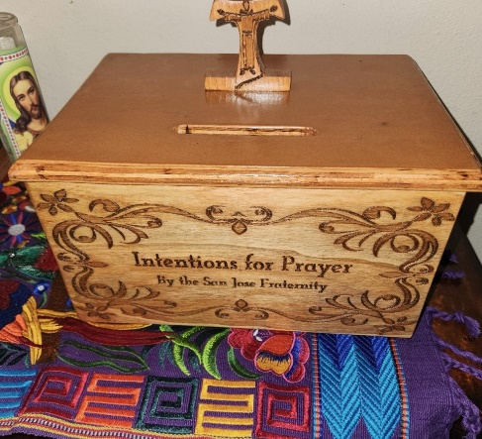

Apostolate for Food Banks: Please bring can goods (the Pop-Top kind only) to our monthly gatherings. We will collect these and distribute to one of our local parishes who have food distribution to the poor.
Apostolate for Homeless: Please bring items to pass to the homeless at the breakfast at Our Lady of Guadalupe Shrine. Needed are: SOCKS, Hats, Glover, Scarfs, small toiletry items.
Food for the Homeless: At Our Lady of Guadalupe Shrine, Franciscan Outreach Ministry is at work every week usually in the mornings (Mon, Tues, Wed, & Fri) around 8:00am. We can try to help in the kitchen during the week. They start cooking around 8:30am.
Catechism of the Catholic Church
276. Where does the Eucharist fit in the divine plan of salvation? The Eucharist was foreshadowed in the Old Covenant above all in the annual Passover meal celebrated every year by the Jews with unleavened bread to commemorate their hasty, liberating departure from Egypt. Jesus foretold it in his teaching and he instituted it when he celebrated the Last Supper with his apostles in a Passover meal. The Church, faithful to the command of her Lord, "Do this in memory of me" (1 Corinthians 11:24), has always celebrated the Eucharist, especially on Sunday, the day of the Resurrection of Jesus. Further reading: CCC 1333-1344
277. How is the celebration of the Holy Eucharist carried out? The Eucharist unfolds in two great parts which together form one, single act of worship. The Liturgy of the Word involves proclaiming and listening to the Word of God. The Liturgy of the Eucharist includes the presentation of the bread and wine, the prayer or the anaphora containing the words of consecration, and communion. Further reading: CCC 1345-1355 , 1408

278. Who is the minister for the celebration of the Eucharist? The celebrant of the Eucharist is a validly ordained priest (bishop or priest) who acts in the Person of Christ the Head and in the name of the Church. Further reading: CCC 1348, 1411

279. What are the essential and necessary elements for celebrating the Eucharist?
The essential elements are wheat bread and grape wine. Further reading: CCC 1412

Pax et Bonum! Peace and All Good!! ¡Paz y Bien!
Suzanne Salinas-Valdillez, ofs, Minister; 7710 Tourney Oak Dr. San Antonio, TX 78223

